Quadcopter Instructables

Group Members:
Chris Polizzi
Matthew Rossett
Karen Haberland
Brian Dixon

*Need a pretty picture of the copter here, if possible*

Step 1: Acquire Components
Quad Battery Pack
Motors (4) make sure 2 spin clockwise and 2 spin counterclockwise
Propellers (4x 11inch diameter)
Speed Controllers (4)
Aluminum sheet (12” by 12” by 1/8”)
Aluminum strips (1” by 9”) (Need 4)
Screws (12x the type of mounting screws needed for the motors)
Arduino Uno
Xbee
Xbee shield
Gyroscope
Controller

Step…: Design the frame
The frame design consists of a 5” by 5” aluminum square with four 1” wide arms protruding from the corners. The arms protrude 8.75” in order to allow for clearance of the 11” propellers. The holes on each arm include four mounting holes for the motors, a clearance hole for the spinning motor shaft, and a mounting hole for the legs. Care was taken that the entire frame design be symmetrical, as any eccentricities would cause flight instability. The frame was designed to be both lightweight and highly supportive by using a skeletonized design with truss supports across the arms. The design was drawn up in Solidworks and fabricated using the laser cutter.
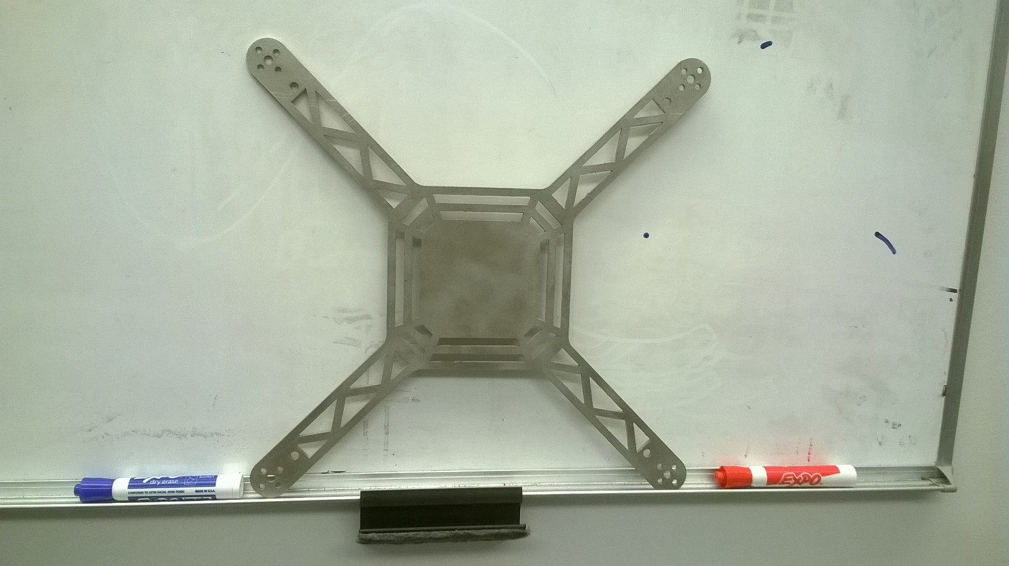

Our original frame utilized a tough plastic 1/8” sheet in this shape, as seen in the figure below. We believed that this material was a good one to use because it was so light. Unfortunately, the motor/propeller combination that we chose was quite powerful and therefore exerted enough force on the arms to make them bend. Thus, we switched to the more durable aluminum sheeting that can withstand the extra force. However, if the aim is for a light, less powerful machine, this material is still a good option. Just make sure you use smaller equipment.

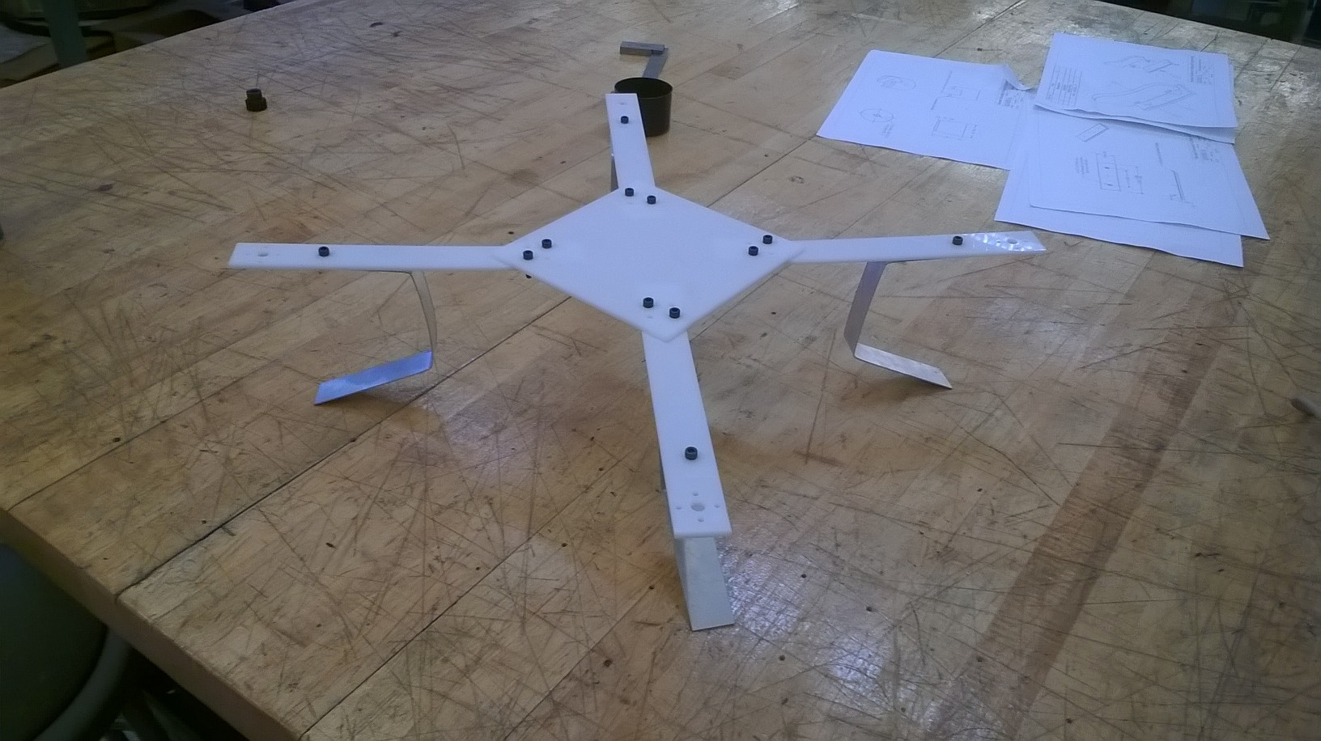

Step…: Mount the motors
Screw all four motors into the given spaces on the top of each arm. It is important here to ensure that the propellers are mounted far enough away from each other that they won’t hit each other when the copter is in flight.

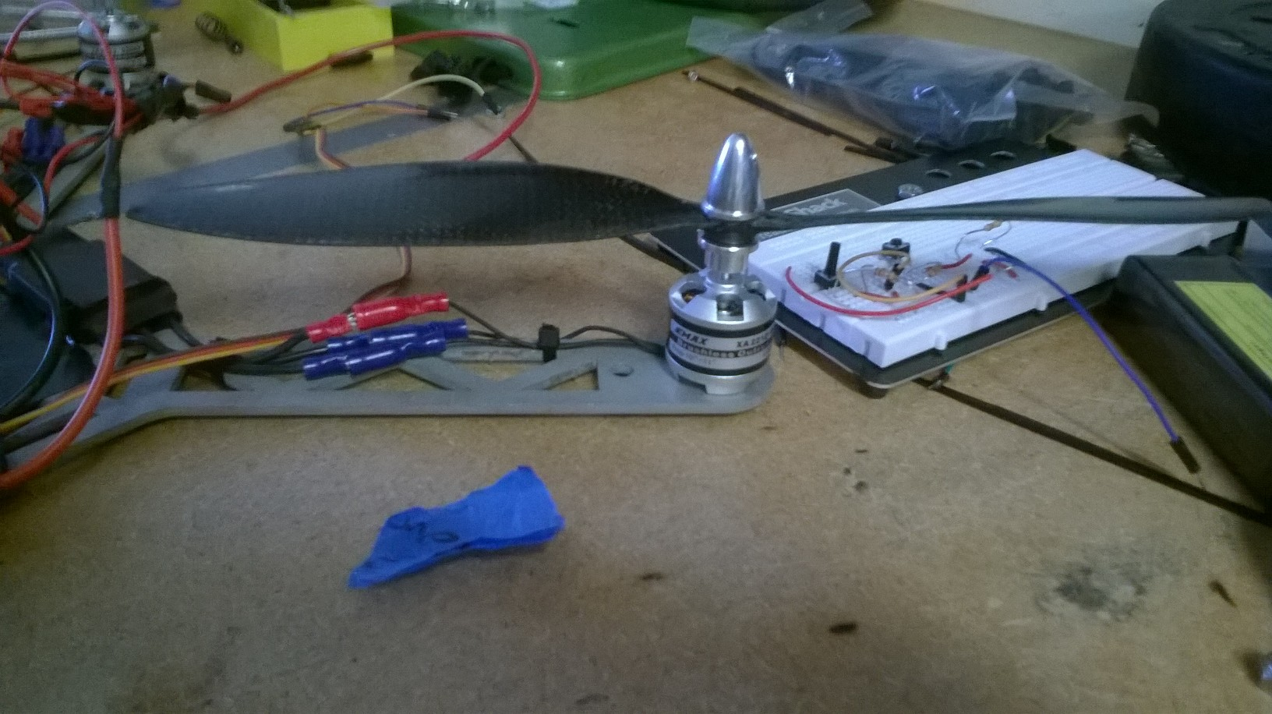

Step….: Add the legs
Take the 1” by 9” strips and bend them into a U shape, with 1” by 4” by 4” side lengths. The shortest side was used allow for flush mounting to the underside of the quadcopter arms. It’s ok if the bends aren’t quite 90 degrees. This gives the legs a bit of spring that eases the landing.

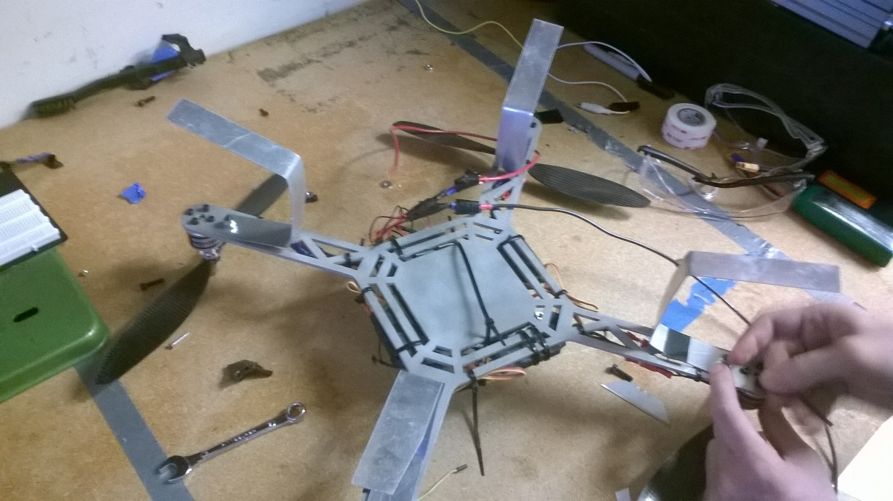

Step…: Write the controller code
…..

Step..: Wiring
….

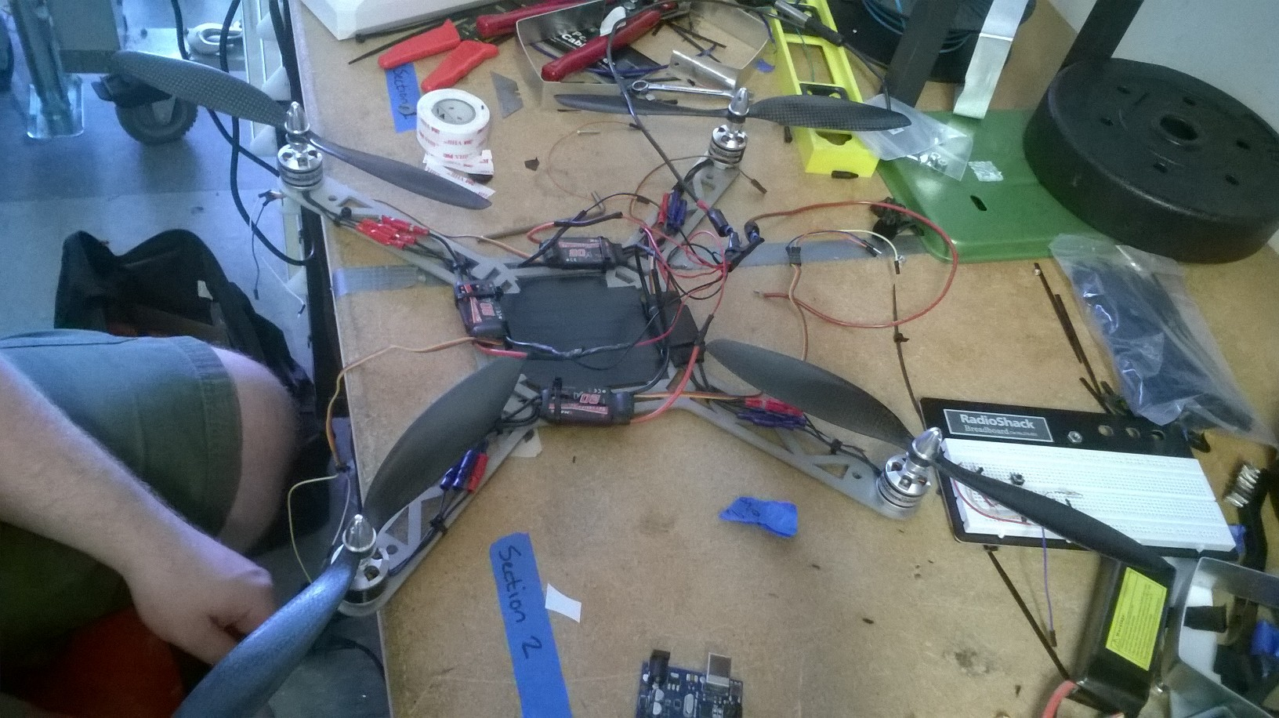

Step…: Mount the Arduino, Xbee, and gyroscope
…..

Step…: Test the motors
While testing the motors to make sure they all worked properly, the copter was held down with a series of weights. This ensured that the copter didn’t damage itself by flying into anything while the motors were fine-tuned.
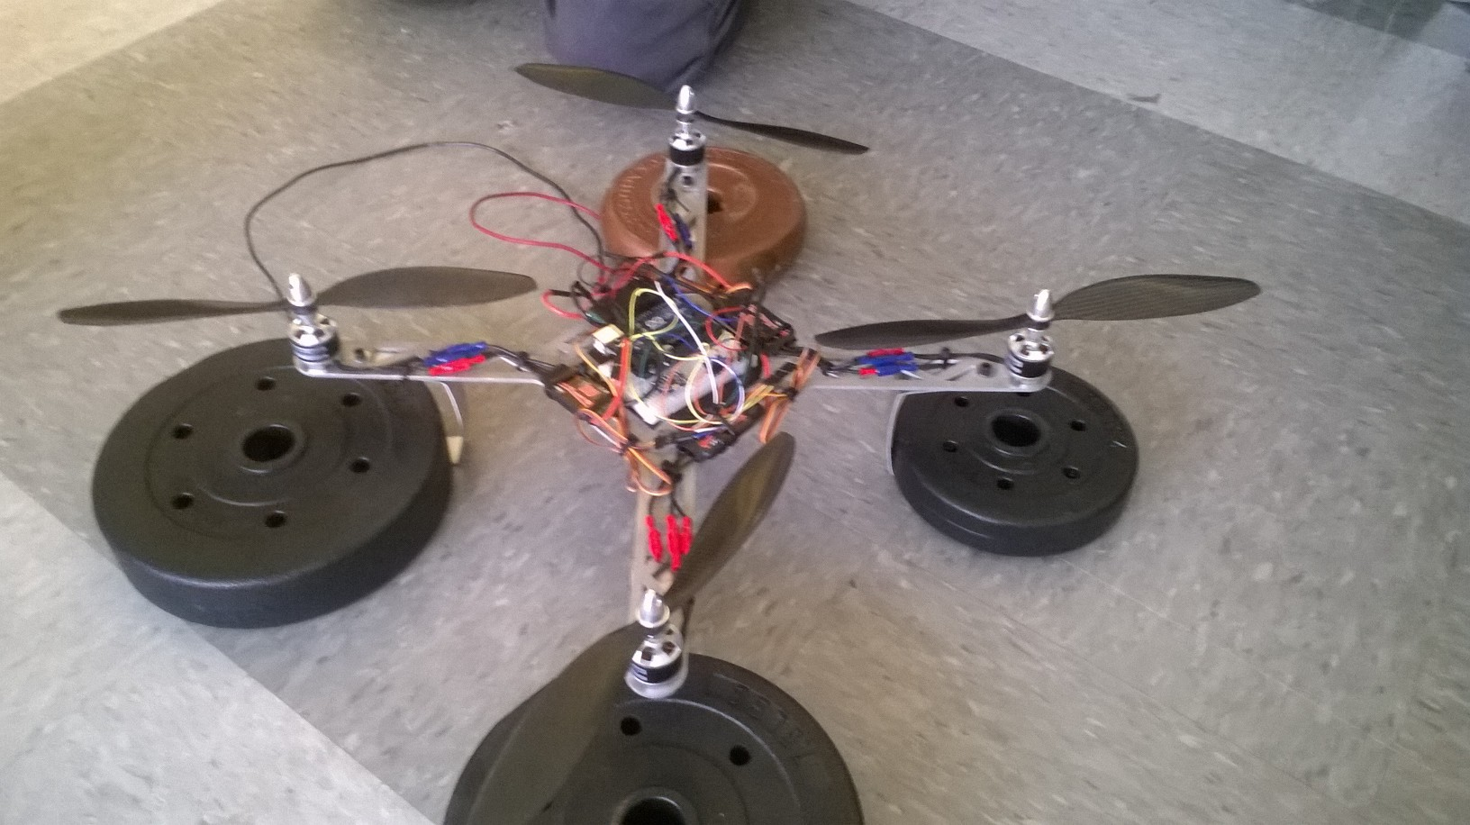

Step…: Balance control troubleshooting
Ideally, the quadcopter should be able to balance itself mid-flight with the use of the gyroscope.
……

Step….: Enjoy your quadcopter!
Now that everything’s been built and tested, the copter can be used as desired. Hang an iPhone from the center supports and film the skies, or buzz the crowd at graduation next week!

