**How to Make a Cricut Molecule Card**

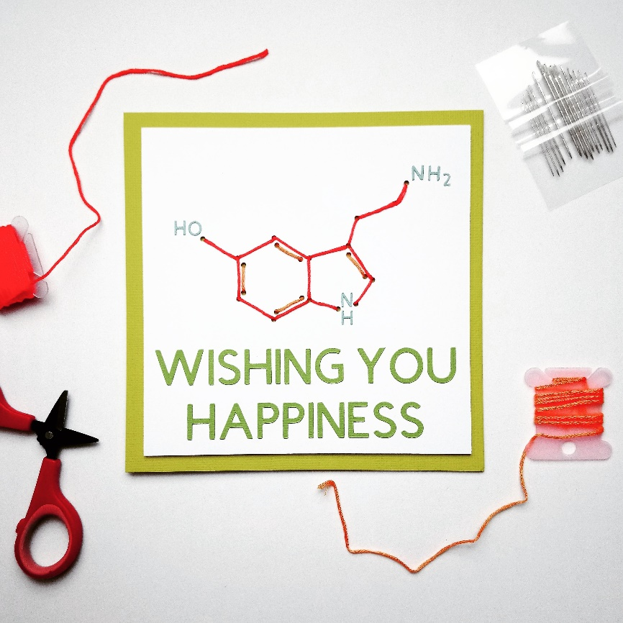

**You will need:**

Cricut Machine (Explore or Maker) with fine point blade

Standard Grip Mat

Laptop/ Tablet/ Computer with internet access

Different colours of cardstock

Embroidery thread

Needle

Scissors

Paper trimmer

Glue pen

**How to make it:**

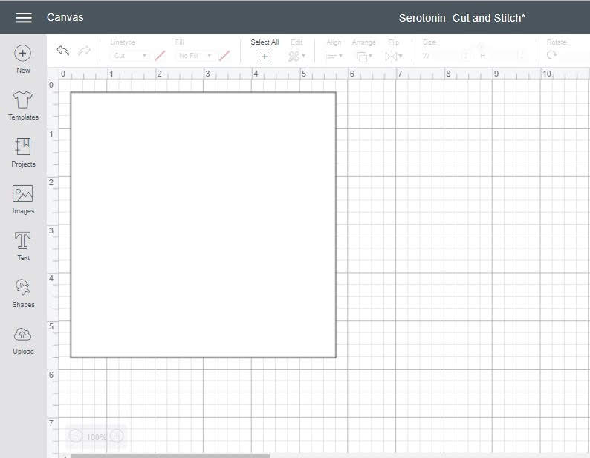

1. To begin, draw a square on your canvas. You can select a square under ‘shapes’ on the left-hand panel. Using the panel across the top, change the size of your square. I made mine 5 ½ inches, but you can change this measurement depending on what size you’d like your card to be. The square automatically is set to the ‘cut’ function, which is the correct setting as this will be the front of our card. I changed the colour of my square to white using the top panel because a) I plan to cut it on white card and b) when I design on top of the square, it makes my work easier to see.

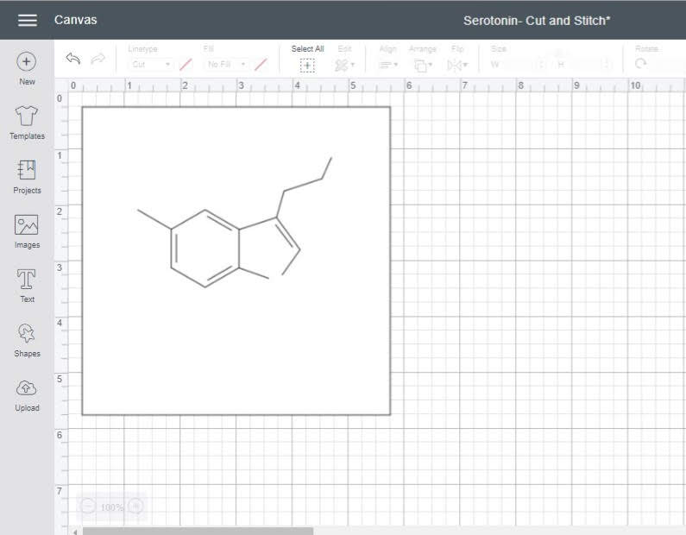

1. Next, draw out your molecule using a series of lines. You can find the lines under ‘shapes’ on the left-hand panel. Under linetype on the top panel, you want to set these lines as ‘draw’. Ultimately, this bit doesn’t matter as the lines are only a guide for the moment. They will help us with the next step without featuring on our finished project! Select all of your lines and attach them to your square using the button to the right of your screen (not pictured here). This tells your Cricut that these lines have to be drawn as they appear and cannot be moved. The Cricut naturally wants to be as economical as possible with space when making projects, so will rearrange them to fit in the smallest space possible. Attaching your lines tells the machine not to do this.

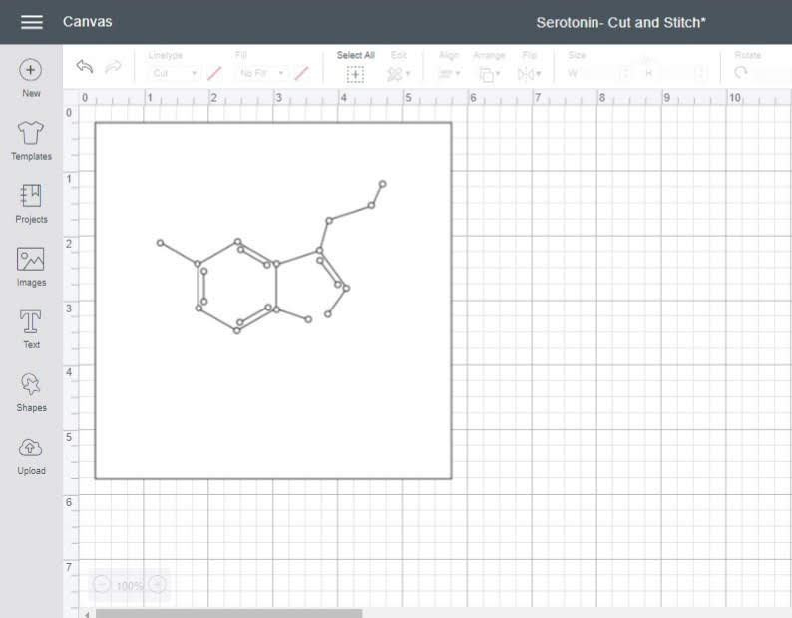

1. Select circle from the ‘shapes’ tab and draw a tiny circle (less than 1/8 inch in diameter). The circle should be big enough to pass an embroidery needle through without having to pull on the paper. These holes need to be set to the ‘cut’ setting as they will be the holes through which you stitch the bonds of your molecules. I found it useful to copy and paste the same circle multiple times as this ensured they were all a uniform size. Position your circles at the intersections of your lines and, once again, ‘attach’ them so everything stays together.

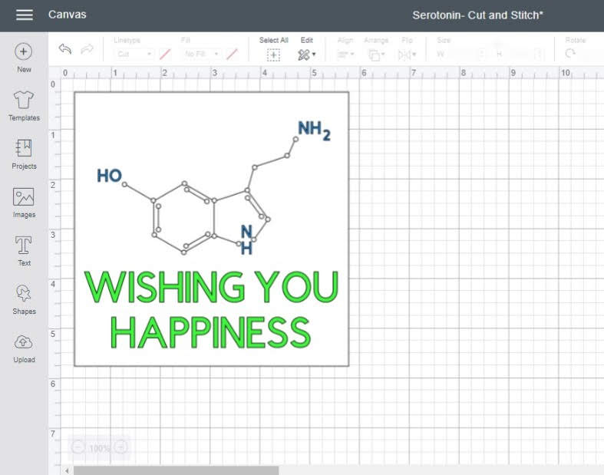

1. Now add your sentiment and details to your molecule. I selected two different colours so that my machine understood that I wanted them cut from different colours of cardstock. The chemists among us will (hopefully) get a little chuckle out of the sentiment ‘Wishing you Happiness’. This card features a serotonin molecule- a neurotransmitter associated with happiness. Serotonin has the chemical formula C10H12N2O and is arranged like the molecule on the card.

When choosing your sentiment and other details, it is worth bearing in mind that your Cricut will cut them out. If they are too tiny, they can be incredibly fiddly to arrange neatly. A tip to help with arranging your wording is to keep the negative space that it cuts from. Position the negative space on your card and piece in the letters like a jigsaw puzzle. This helps to keep letters evenly spaced and in a straight line. I find that using a glue pen works better than traditional PVA glue or a glue stick. It is generally less sticky, requiring you to work quickly, but the results are often much neater when it comes to fiddly projects.

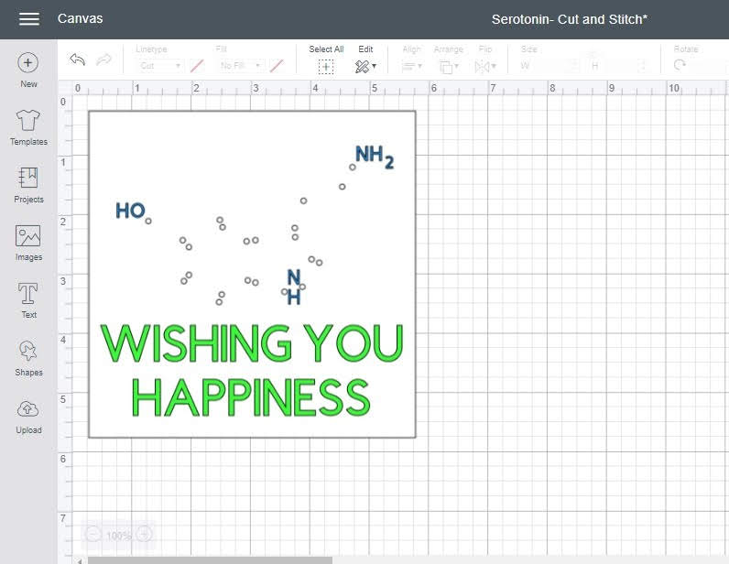

1. Hide the lines you drew using the eye symbol on the right hand side of your canvas (not pictured). This doesn’t delete them, just tells your machine not to draw them when you make the project. This will allow for a much neater finished project as you will not be stitching on top of drawn lines, instead, your stitching creates the bonds in your molecule.

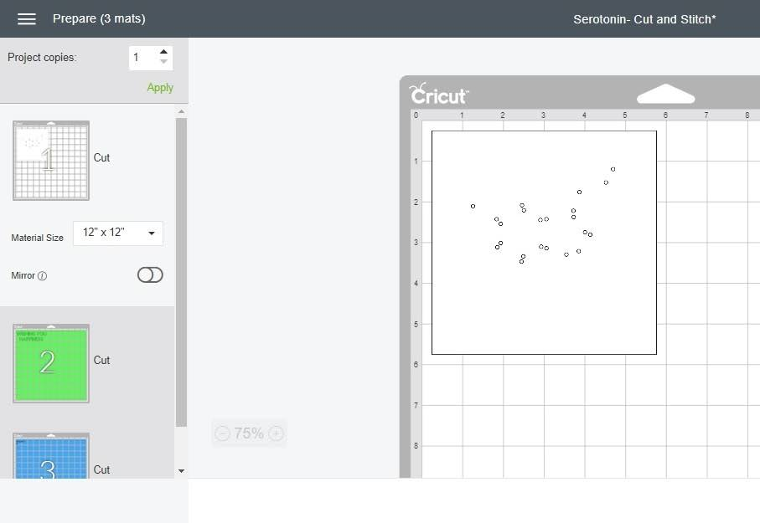

1. When you hit ‘make it’, you will notice your project is on 3 different mats. The first mat is the piece you will stitch; it only has holes cut into it. The second and third each have parts of the sentiment which will cut from separate pieces of paper. Follow the instructions on your screen to make your project, cutting one mat at a time. If using a Cricut Explore, turn your dial to the ‘cardstock’ setting. If using a Cricut Maker, select ‘cardstock’ from the list of materials.

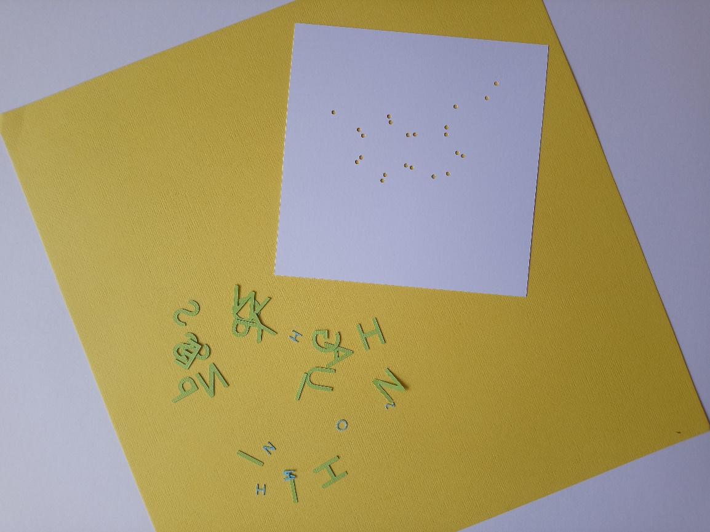

1. Once everything has been cut out, keep your pieces safe! Some of them will be tiny. Don’t throw away the negative space as this will help you to position your letters. Choose a piece of cardstock in a coordinating colour on which to mount your card later on. I have chosen a happy yellow.

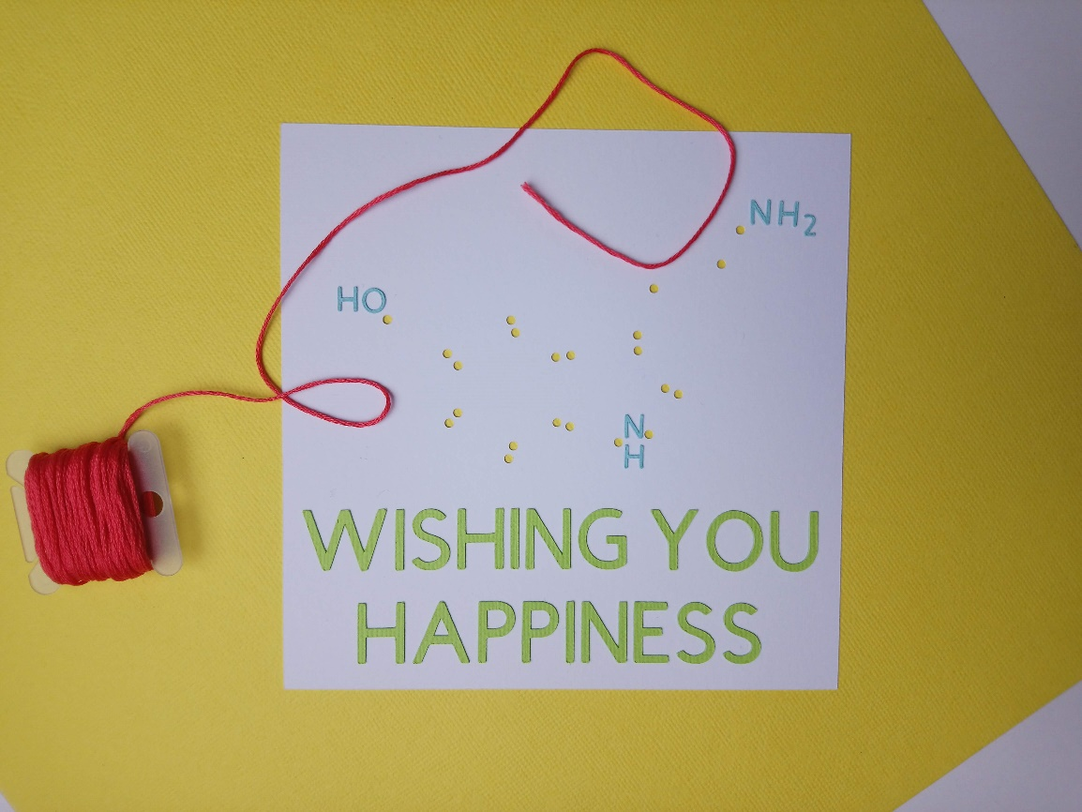

1. With your tiny letters adhered to your card in the correct place, all that’s left to do is to stitch your molecule! I find that using a small piece of tape to stick the end of the embroidery thread to the back of your card does the trick and helps the front of the card stay flat. Once you have stitched your card, mount it onto a piece of your coordinating cardstock trimmed to 12x6 inches and scored in half to make a 6-inch square card.

