**[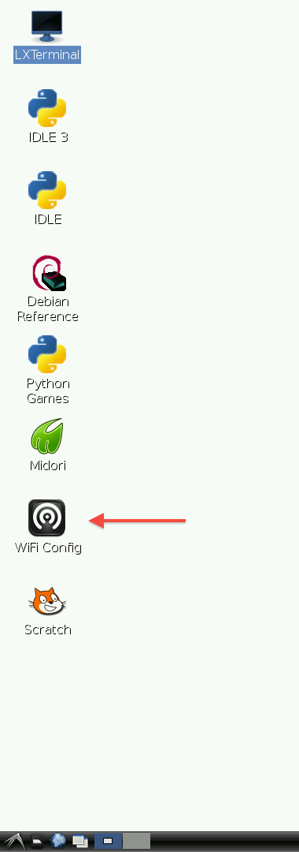](https://learn.adafruit.com/assets/2924)FOR OLDER VERSION**

**Step 1.**

Double-click the icon and this is what you will see.

[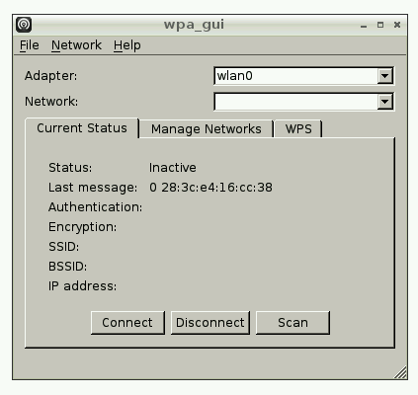](https://learn.adafruit.com/assets/2925)

**Step 2.**

Click on the Scan button and a second window will open. Find your Wireless access point in the list and double click on it. This will open another window.

[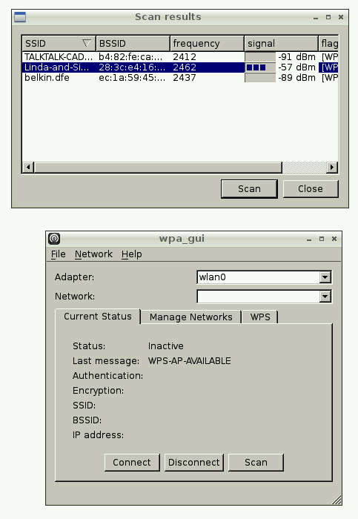](https://learn.adafruit.com/assets/2926)

**Step 3.**

Enter your password in the PSK field and then click Add. When you look at the first window, you should see that the connection is all set up for use. You can connect or disconnect using the buttons. Notice also the IP address of the Pi is shown at the bottom of the window.

[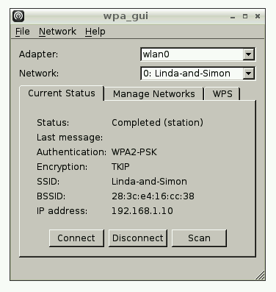](https://learn.adafruit.com/assets/2927)

**FOR NEWER VERSION**

Wifi connections can be made via the network icon at the right-hand end of the menu bar. If a wi-fi dongle is plugged in, left-clicking this icon will bring up a list of available wi-fi networks, as shown. (If no networks are found, it will show the message "No APs found - scanning..." - just wait a few seconds without closing the menu, and it should find your network.)

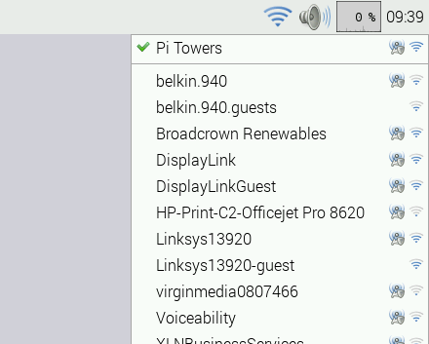

The icons on the right show whether a network is secured or not, and its signal strength. Click the network that you want to connect to; if it is secured, a dialog box is shown prompting you to enter the network key.

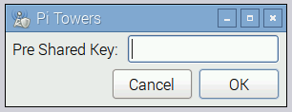

Enter the key and press OK, then wait a couple of seconds. The network icon will flash briefly to show that a connection is being made; once it is ready, the icon stops flashing and shows the signal strength.