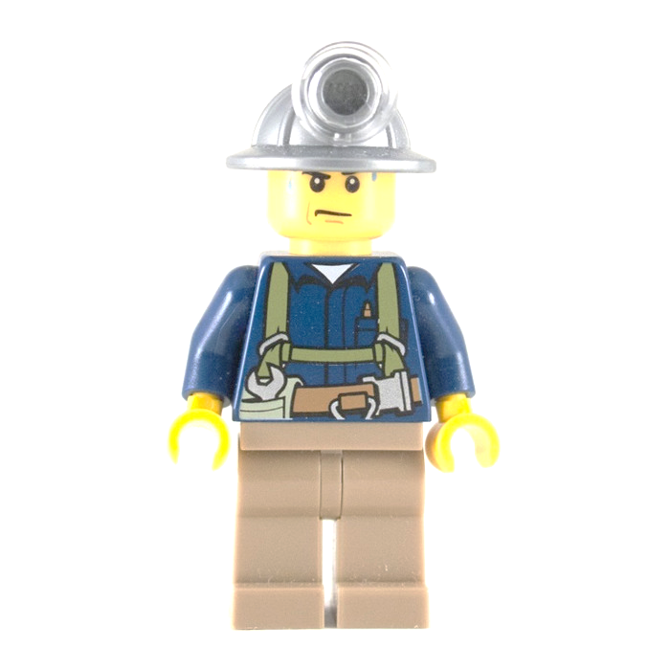

**SELECT ENTER**



**RADIAL FRACTURE**

**HOPELESS CASE**

**WRENCHED KNEE**

**INNER CHILD**

**FUNNY BONE**

**MENTAL BLOCK**

**ON/OFF**