

**It’s All in the Mind- Brain Challenges**

**Name:____________________________**

**The Frontal Lobe**

Responsible for forward thinking, planning and decision making!

**Challenge:**

Time yourself reading the words in black (1) and record your score. Then, time yourself saying out loud the *colours* of the words (2), not the word that is written. Compare your scores- what do you notice?

**RED GREEN BLUE BLACK YELLOW PURPLE ORANGE RED PINK YELLOW ORANGE RED BLUE BLACK BROWN GREEN GREY BLUE PINK RED**

**1.**

**GREEN YELLOW BLUE BLACK PINK BROWN RED GREEN PURPLE GREY BROWN PINK YELLOW BLUE PURPLE ORANGE RED YELLOW BLACK**

**2.**

**Scores**

|  |  |  |
| --- | --- | --- |
| **Player** | **Time 1** | **Time 2** |
|  |  |  |
|  |  |  |
|  |  |  |
|  |  |  |
|  |  |  |
|  |  |  |
|  |  |  |
|  |  |  |
|  |  |  |
|  |  |  |
|  |  |  |
|  |  |  |
|  |  |  |
|  |  |  |
|  |  |  |
|  |  |  |
|  |  |  |
|  |  |  |
|  |  |  |

**The Parietal Lobe**

Processes information from our senses including taste, temperature and touch!

**Challenge:**

Have your partner sit with his or her back to you. Using your finger, gently trace the outline of a word or picture on their back. Can they guess what you have drawn? Take it in turns and see who can guess what their partner has drawn!

**Scores**

|  |  |  |
| --- | --- | --- |
| **Guesser** | **What was drawn?** | **Did they guess correctly?** |
|  |  |  |
|  |  |  |
|  |  |  |
|  |  |  |
|  |  |  |
|  |  |  |
|  |  |  |
|  |  |  |
|  |  |  |
|  |  |  |
|  |  |  |
|  |  |  |
|  |  |  |
|  |  |  |
|  |  |  |
|  |  |  |
|  |  |  |
|  |  |  |
|  |  |  |
|  |  |  |

**The Temporal Lobe**

Processes auditory information (sounds and language)

**Challenge:**

To help you understand just how much your temporal lobe does for you, have a go at lip-reading. Lip-reading is an important skill that is really helpful to people who have difficulty hearing. It is a skill you can learn, but you might be surprised at how much you can do without even realising it!

To put your lip-reading abilities to the test, turn on the TV and put it on mute. Can you still work out what people are saying?

Here are a few things to test:

1. Whose lips are easier to read- a person on the news or your favourite cartoon character?
2. What sorts of things do people do when speaking that make lip-reading easier?
3. How easy is reading the lips of your favourite singer when they are singing a song you know well?

**The Occipital Lobe**

Processes visual information (the stuff you see).

When we see something new, we work out what it is by asking ourselves questions: have I seen anything like it before? What is it made of? How has it been put together?

Sometimes, it can take us a while to work out what images are when we are looking at them in a different way.

Here are several zoomed-in images of things you may have seen before, but probably haven’t looked at this close up! Can you work out what they are?

**Hint:** some of the pictures are of living things!

**Stuck?:** Work with a partner so they can give you clues to help you work out each picture.

The answers are at the back of the booklet!

1. 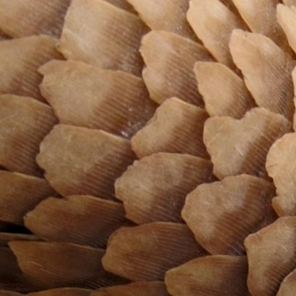
2. 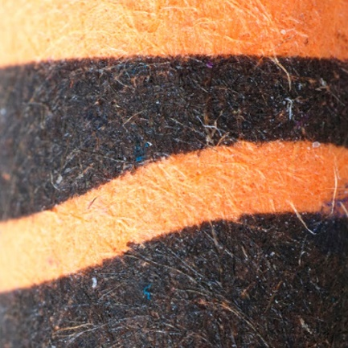
3. 
4. 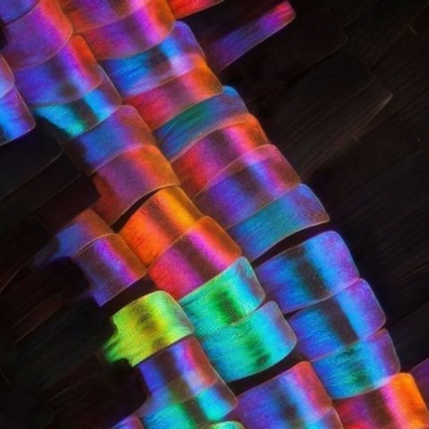
5. 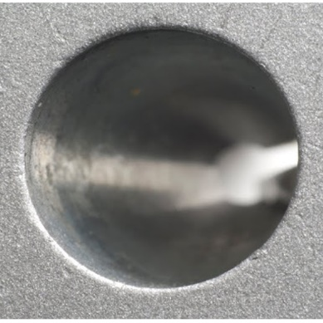
6. 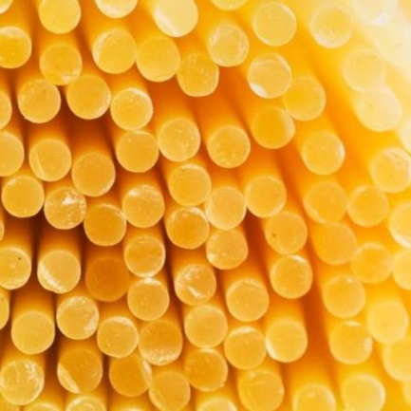

**The Cerebellum**

In charge of balance and coordination.

**Challenge:**

**Reaction time test.** Have your partner hold a ruler just above your hand, with your fingers pinched together. Grab the ruler as quickly at you can when they drop it. Your score is the distance the ruler travelled in centimetres. The shorter the distance, the quicker your reaction time!

|  |  |  |  |  |
| --- | --- | --- | --- | --- |
| **Player** | **Score 1** | **Score 2** | **Score 3** | **Average** |
|  |  |  |  |  |
|  |  |  |  |  |
|  |  |  |  |  |
|  |  |  |  |  |
|  |  |  |  |  |
|  |  |  |  |  |
|  |  |  |  |  |
|  |  |  |  |  |
|  |  |  |  |  |
|  |  |  |  |  |
|  |  |  |  |  |
|  |  |  |  |  |
|  |  |  |  |  |
|  |  |  |  |  |

**Balance test.** Stand on one foot, otherwise unsupported. Use a stopwatch to time yourself doing so. The longer you stand without wobbling, the better your balance!

|  |  |  |  |  |
| --- | --- | --- | --- | --- |
| **Player** | **Time 1** | **Time 2** | **Time 3** | **Average** |
|  |  |  |  |  |
|  |  |  |  |  |
|  |  |  |  |  |
|  |  |  |  |  |
|  |  |  |  |  |
|  |  |  |  |  |
|  |  |  |  |  |
|  |  |  |  |  |
|  |  |  |  |  |
|  |  |  |  |  |
|  |  |  |  |  |
|  |  |  |  |  |
|  |  |  |  |  |
|  |  |  |  |  |

Often, our reaction time and ability to balance are much better when we are young. Is there anything you are noticing about your scores compared with those of others?

**Answers: The Occipital Lobe**

1. Anteater

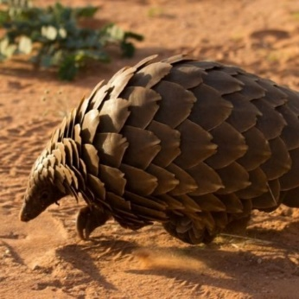

1. Crayon

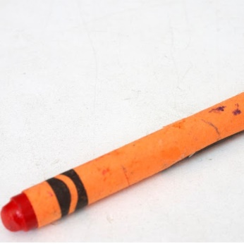

1. Grapefruit

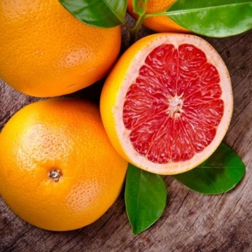

1. Butterfly

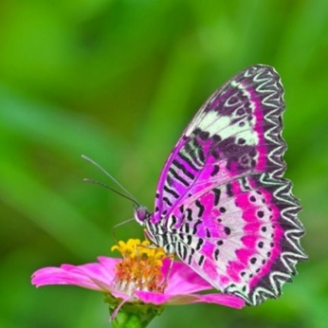

1. Pencil Sharpener

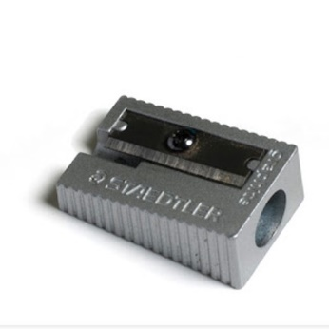

1. Spaghetti

