## 1 2 3 4

A

## B

C

## D

E

## 5 6 7 8

Vista home

A

## B

C

## D

E

Dept.

Technical reference

Created by

# Fabricio Cuba

Document type

# 30/04/2021

Approved by

Document status

Title

F PARTE_2

DWG No.

## F

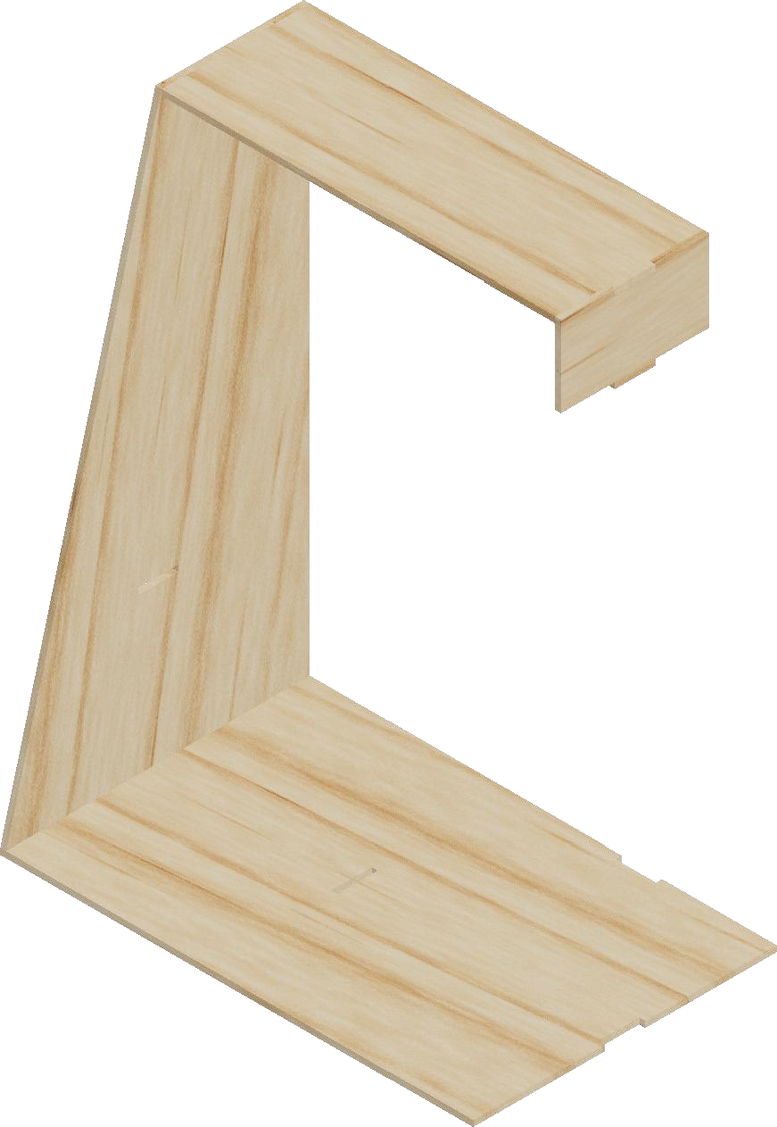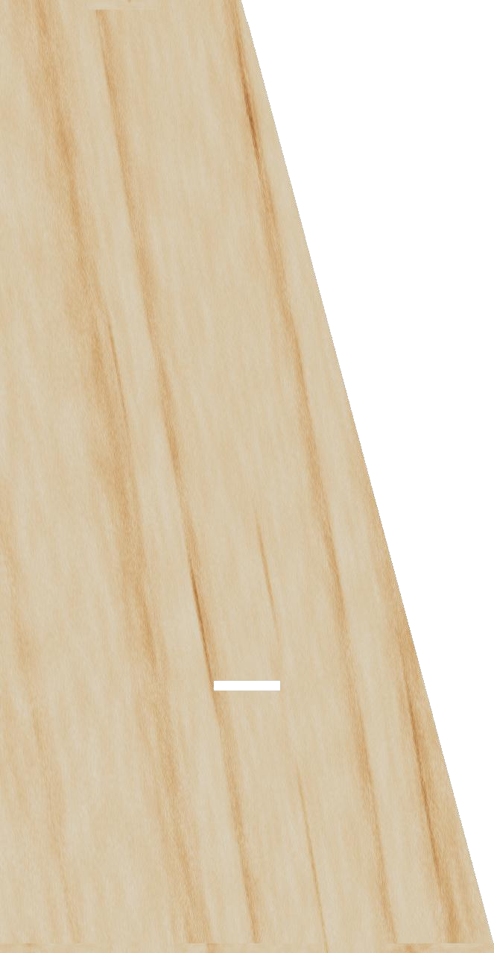

1 2 3 4

## 5 6 7

Rev.

Date of issue

Sheet

# 1/4

## 8

1 2 3 4 5 6 7 8

# 17

## A

1. B

19.5

## C

45

1. D

10

1. 70 E

# 30

Parte inferior

F

Dept.

Technical reference

Created by

# Fabricio Cuba

Document type

Title

PARTE_2

# 30/04/2021

Approved by

Document status

DWG No.

## F

Rev. Date of issue Sheet

# 2/4

## 1 2 3 4 5 6 7 8

