**Saltwater Battery Lab**

Objective: To provide students an introductory and basic understanding of what electricity is and how it operates.

Age: 14-18 Year Olds

Time Required: 1 Hour

Materials: Plastic Cup or Beaker, Copper Wire or Strip, Aluminum Wire or Strip, Salt, Water, Voltage Meter, Alligator Clips, D Battery, Low Powered Bulb.

1. Take five minutes asking students what electricity is. Do not correct them, allow the students to come up with ideas, right or wrong, and attempt to explain the phenomena.
2. In groups, or individually, have the students create the saltwater battery using the lab guide. Make sure each student receives their own lab guide to follow.
3. Once students have completed their lab guides, bring them back together.
4. Ask students to share their observations, what happened? Why did this happen? Again, don’t correct wrong answers, allow students to share what they think happened.
5. When students are done sharing, construct a closed circuit using the D battery, alligator clips, and a low powered bulb. (Make sure your battery and light are compatible. The battery should have enough voltage to power the light without overloading it.)
6. Ask students to explain what’s happening.
7. Remove ONE END of the clip from the battery, the bulb will shut off.
8. Ask students what happened.
9. Reattach the clip so that the bulb is again lit.
10. Now explain to the students that **electricity** is the flow of tiny particles called **electrons** from a high concentration to a low concentration. Electricity flows like water. A high concentration of electrons flows to a low concentration of electrons. This change in concentration creates electric pressure, or **voltage**. In this case, the positive end of the battery has a high concentration of electrons. The negative end has a low concentration of electrons. The electrons are pushed from the positive end, through the alligator clips, through the bulb, and back to the negative end.
11. The students can’t see this phenomena happening directly. On a white board, demonstrate this flow using a diagram similar to this: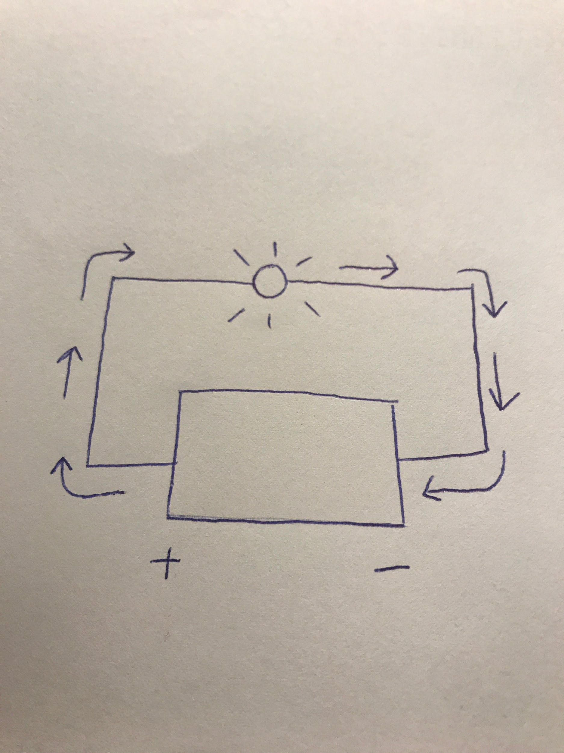
12. Reaffirm that the bulb is lit because of a difference in pressure. Ask the students to identify where this change in pressure occurs. The correct answer is the bulb. The bulb contains **resistance,** opposition to the flow of the current. This resistance reduces the pressure in the circuit.
13. Go back to the water analogy. If electricity flowing is like water, then resistance is like an object in the water. If the object in the water is massive enough, it will slow down the water and decrease the pressure of the water. This is similar to resistance.
14. Now, using the same diagram as before, add color to demonstrate the differences in pressure. Red for high pressure, orange for the next highest, then yellow, green, and blue for low pressure. The diagram should now look like this: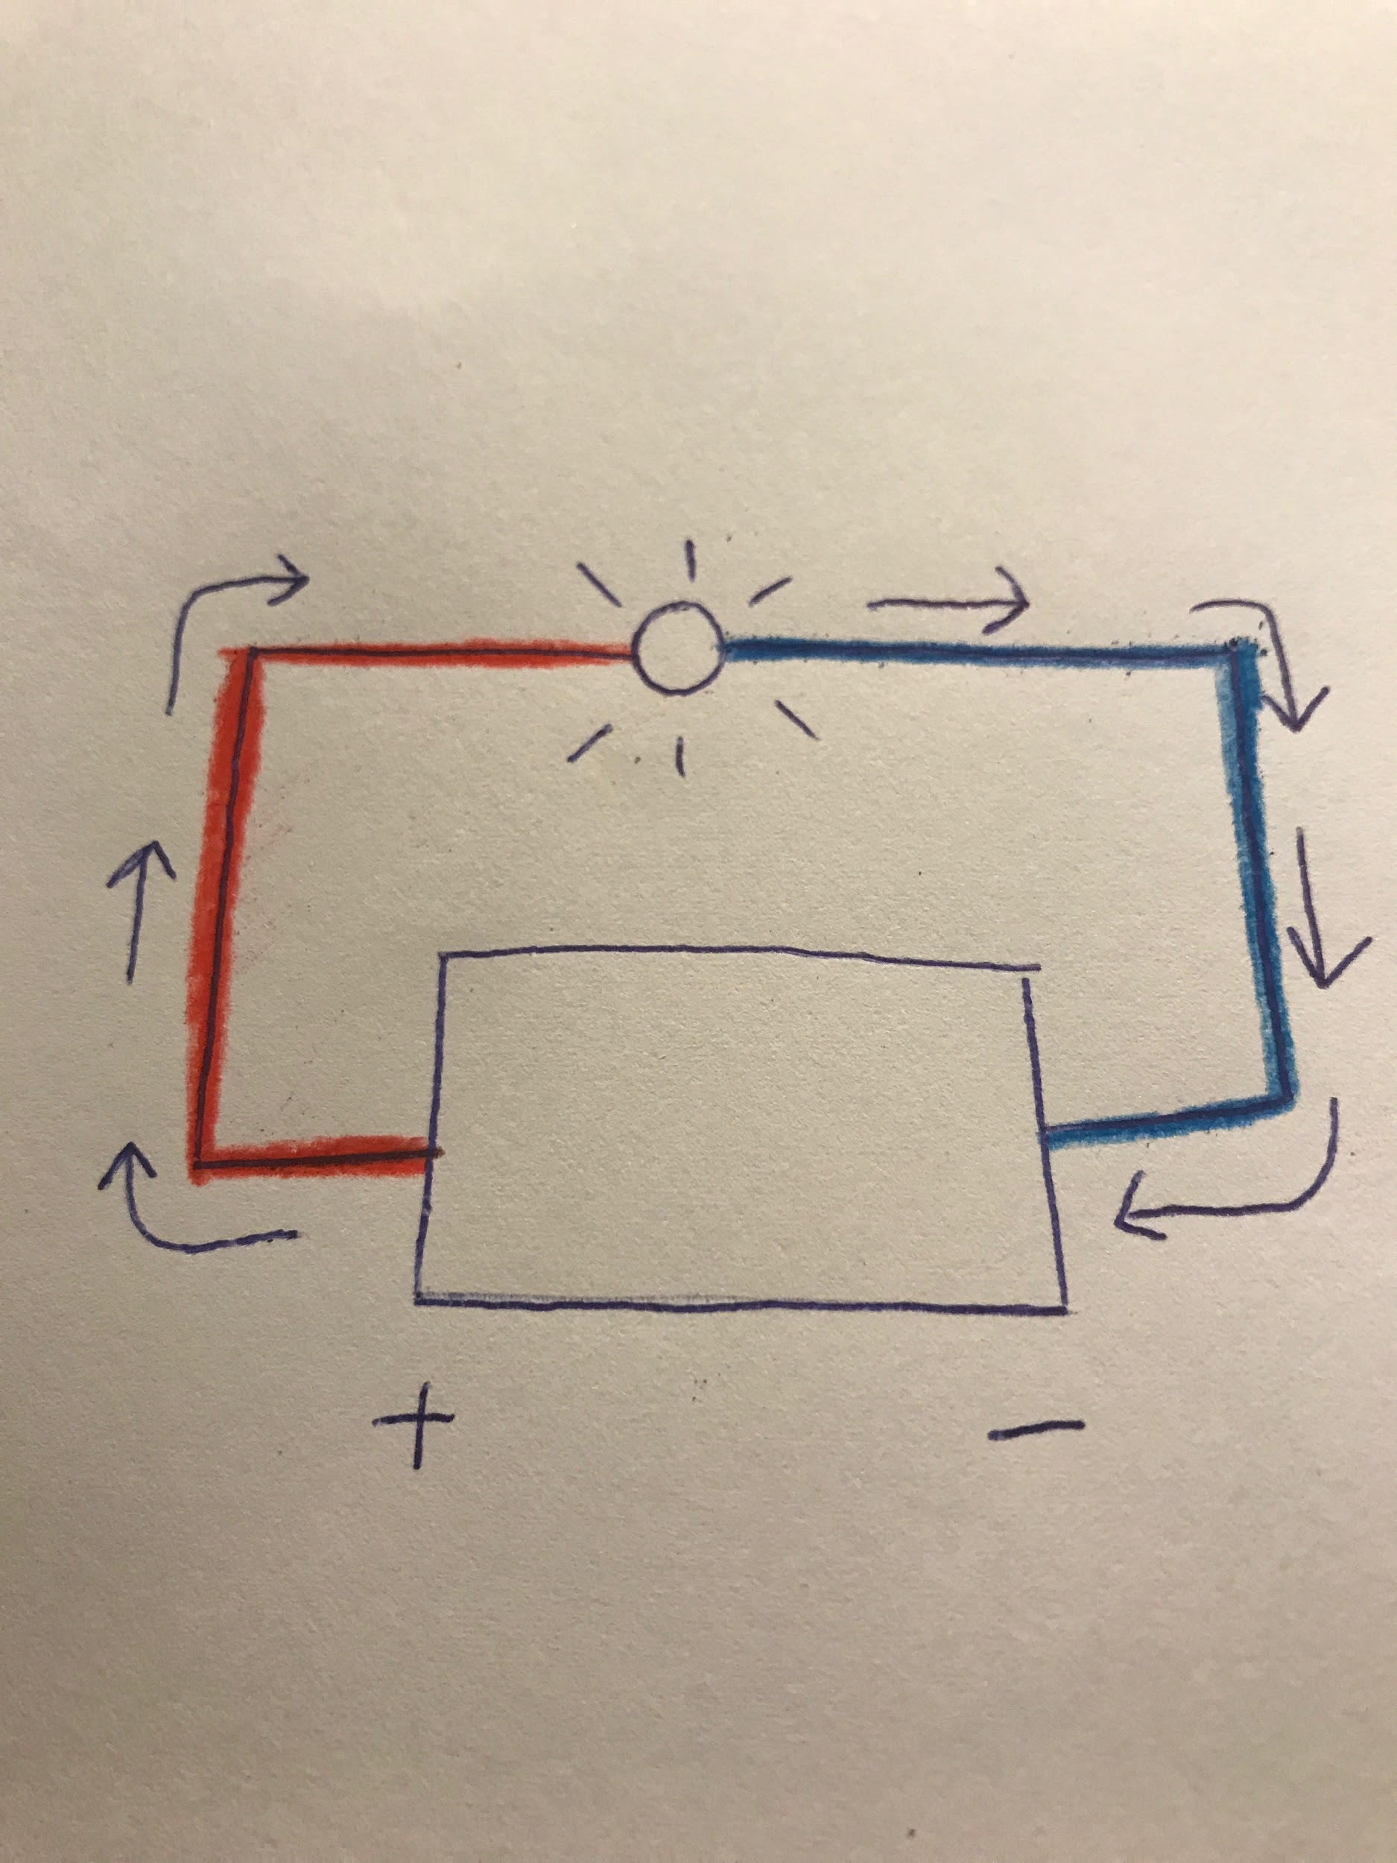
15. Bring the lesson full circle. Explain that the saltwater solution contains ions, a molecule with an electrical charge. Molecules become ionic when they lose or gain an electron. The molecules that lose electrons become positive, and those that gain electrons become negative. Because of the charged ions, a pressure difference is established at the molecular level, allowing electrons to freely flow.
16. Pass out the post lesson assignment. This can be done in class or as homework. This worksheet isn’t meant to be graded. Instead it should be used to allow the students to further research electricity, resistance, and circuits. When the students are finished, allow them to share their answers, using your guide to allow them to correct their answers.

Disclaimer: Obviously there’s much more to learn about electricity. This lesson is meant to give a very basic foundation that students can then build upon. It’s meant to introduce several concepts and strengthen existing knowledge. Thank you!