KK 2.1.5 Quadcopter Trimming Manual
-Teerth Nilesh Warang

Controller Trimming

- Endpoints to 100% Complete
- Controller: Reversing Completed
- Follow the images for Left/Right Trimming and Lever Trimming using Sliders:
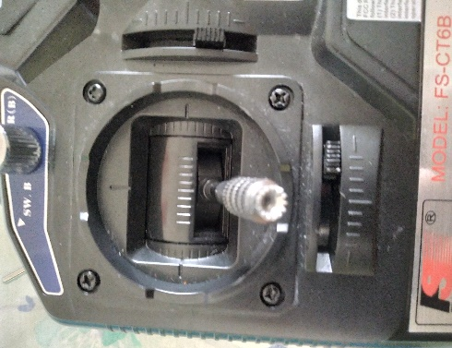 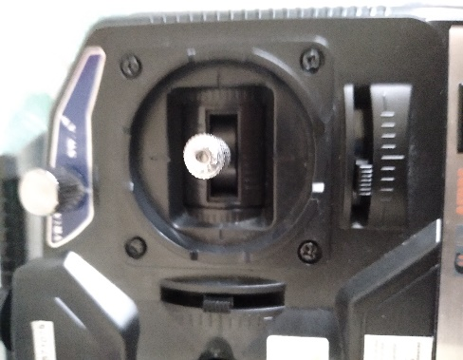 SLIDERS & VR SW (A)

