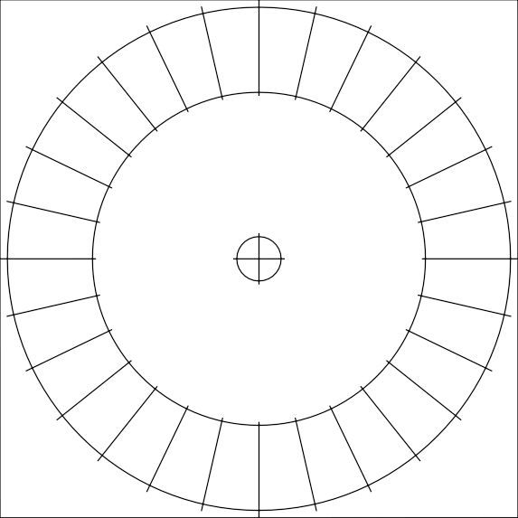
Turbine wheel

Paper size: A4
print control size 70mm
∅6mm
∅ - bore diameter

