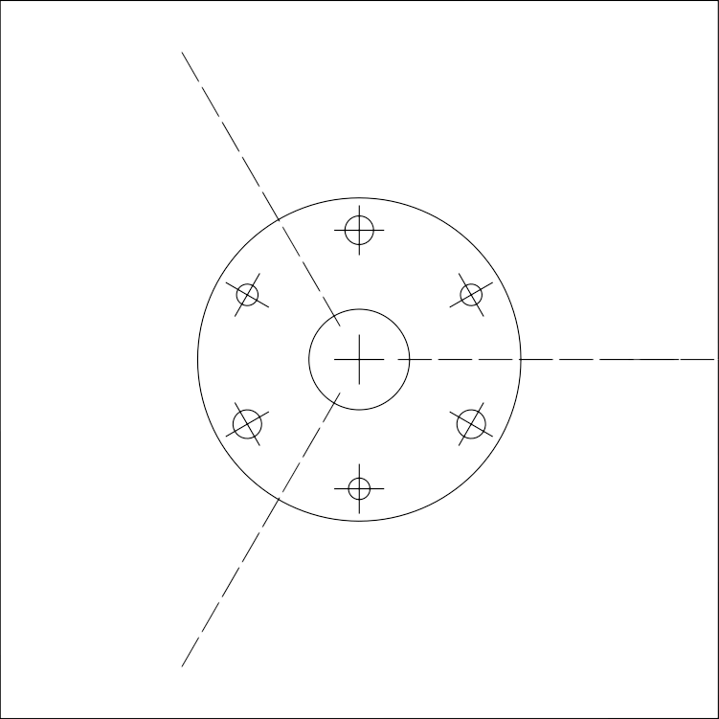
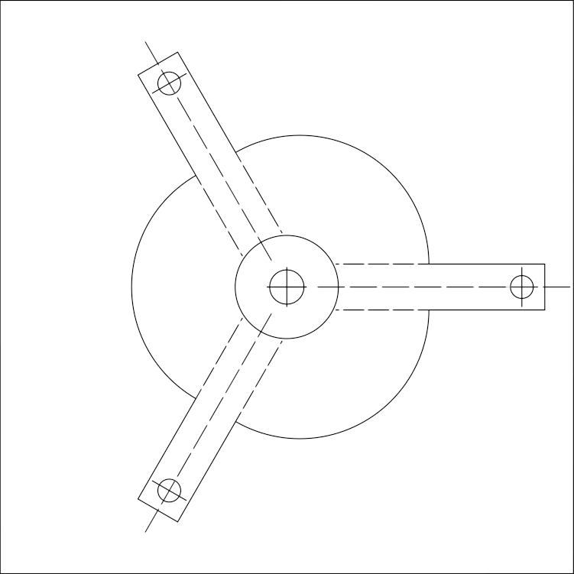
print control size 100mm
Support wheel
first pass

Paper size: A4
Support wheel
second pass
∅18mm
∅3mm
∅3mm
∅4mm
∅ - bore diameter

