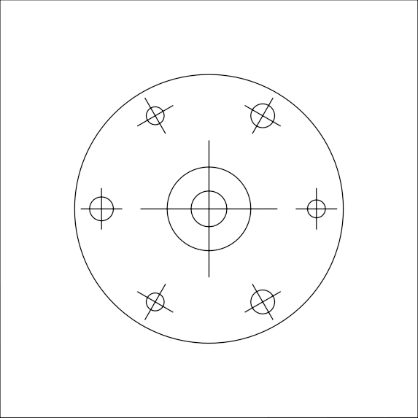
Bigger Metal Spacer

Paper size: A4
print control size 70mm
∅ - bore diameter
∅3mm
∅4mm
∅6mm

