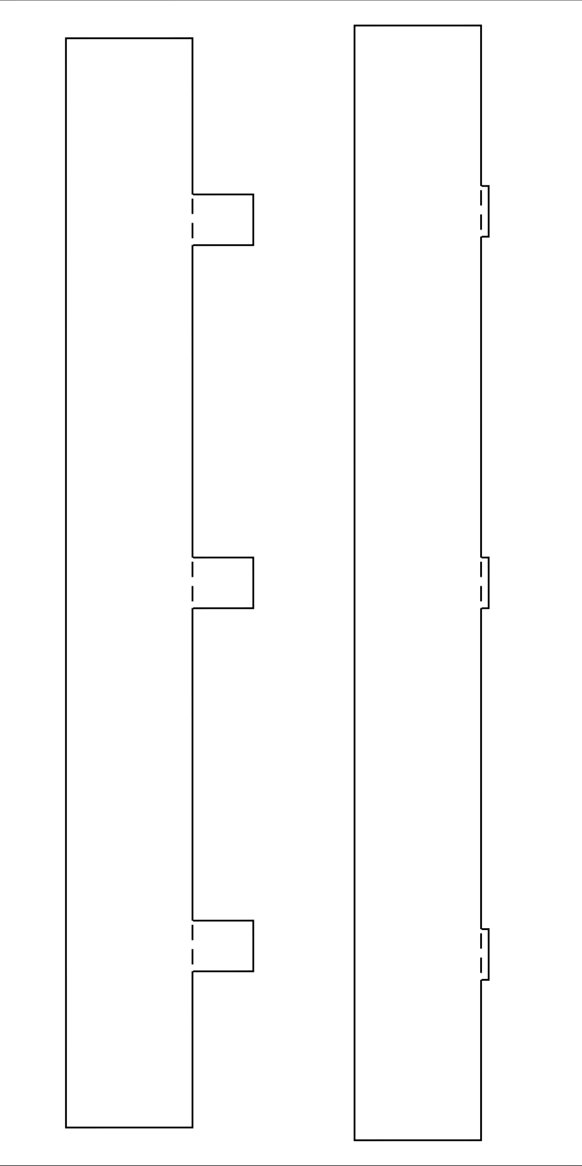
first ring
The turbine shroud

Paper size: A4
second ring
print
control
size
230mm

