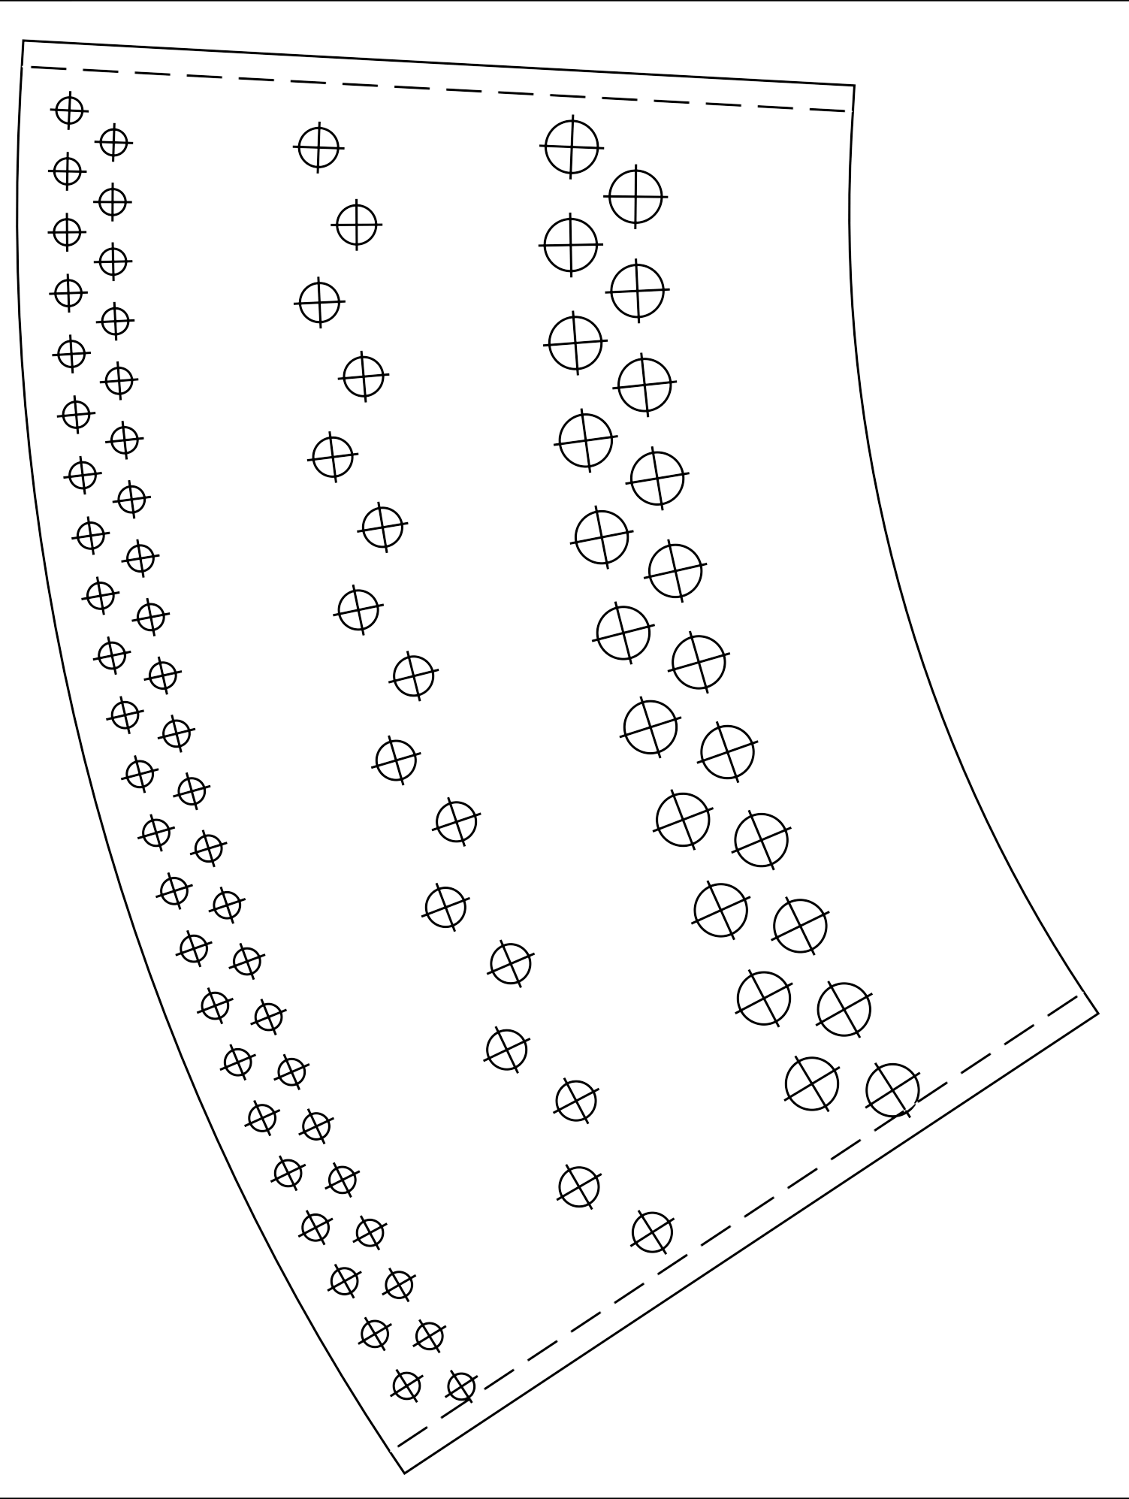
The main part of the liner

Paper size: A4
∅ - bore diameter
∅4mm
∅6mm
∅8mm
print control size 100mm

