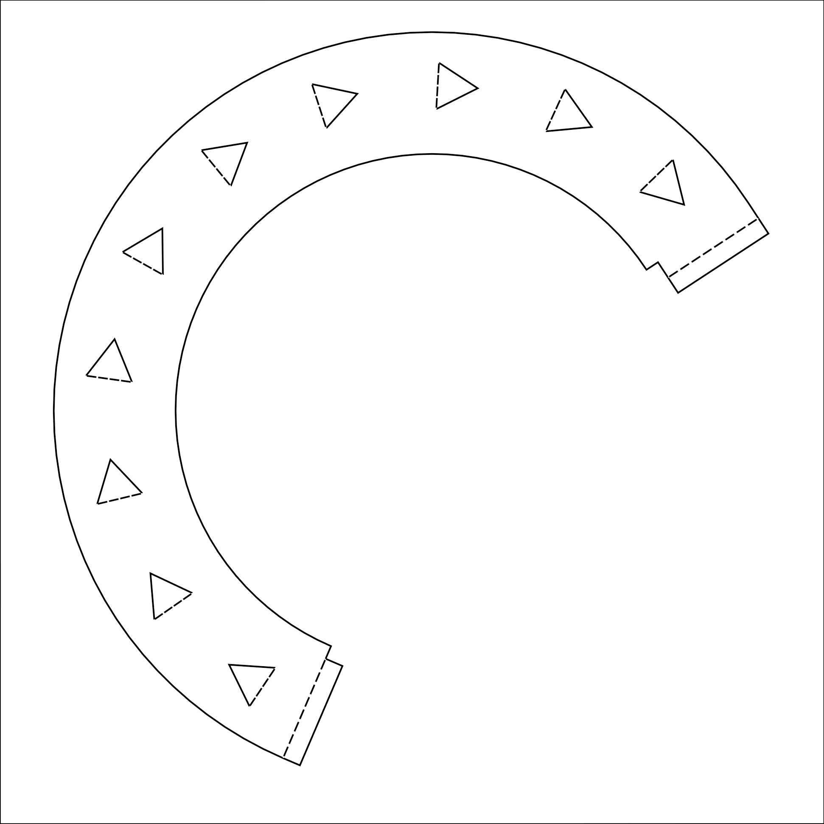
The front part of the liner

Paper size: A4
print control size 100mm

