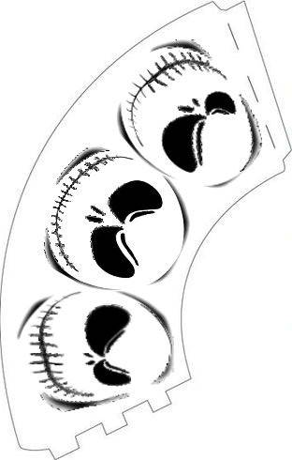

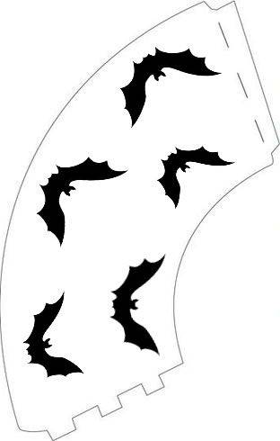

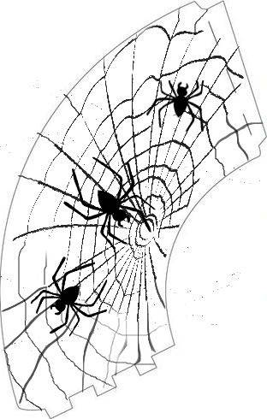

To resize pictures…click on picture..
Then you will get a box round the picture
Now right click on the picture..
You will get some commands
Chose ‘ size and position’
I have chosen 175 percent in size
You can change the percentage to the size you want.
First print one shade in white paper to see if size is ok.

