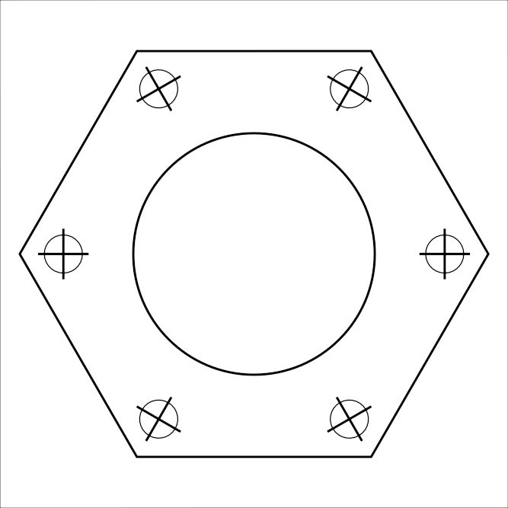
Compressor mount nut

Paper size: A4
print control size
40mm
∅ - bore diameter
∅3mm

