DIY: Harry Potter Birthday Party

Customizable Template

What
This word document is a collection of templates, compiled to help the event organizer. Read the below sections carefully to understand when and how to use this document effectively.

When
Most of the content will be useful as part of the event preparation – e.g the acceptance letters will have to be composed and printed a couple of weeks ahead of the event. It is recommended that the organizer keep referring to this document in parallel, while going through the instructions.

How
The acceptance letter (page number 2) has a lot of text in angular brackets (e.g. <the date>). All these text require customization – to suit the details of the event. One needs to make the appropriate changes before printing them out. Page number 3 can be printed without any modification. In page number 4, locate the text box floating on top of the ticket. Update the text, and print as many tickets as you wish. The seal on page 4 must be cut out after printing and stuck as a seal so as to close the envelope.

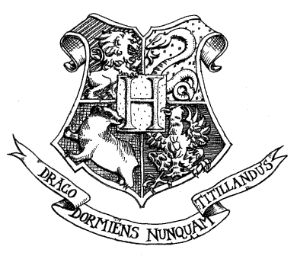
HOGWARTS SCHOOL OF
WITCH CRAFT AND WIZARDRY
Headmistress: Minerva McGonagall
(Former deputy headmistress)

Dear <Mr/Mrs/Ms> <name of the guest>,

We are pleased to inform you that you have been accepted for my birthday party. Please find enclosed the ticket.

Party is on <the date> from <time> till <time>. We await your owl by no later than <a date: e.g. one week before the party>.

Yours sincerely,

<your name>
Party host/hostess


<sign here after printing>

HOGWARTS SCHOOL OF

WITCHCRAFT AND WIZARDRY
UNIFORM

All invites require an apt costume resembling a student/house ghost/ magical creature etc.

COURSE BOOKS

None

OTHER EQUIPMENT

1 cauldron (to carry the goodies)

Students may also bring an owl OR a cat OR a toad

PARENTS ARE REMINDED THAT ALL INVITES ARE REQUIRED TO CARRY THEIR OWN BROOMSTICKS.

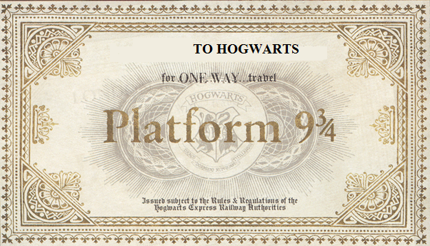
<your city>

