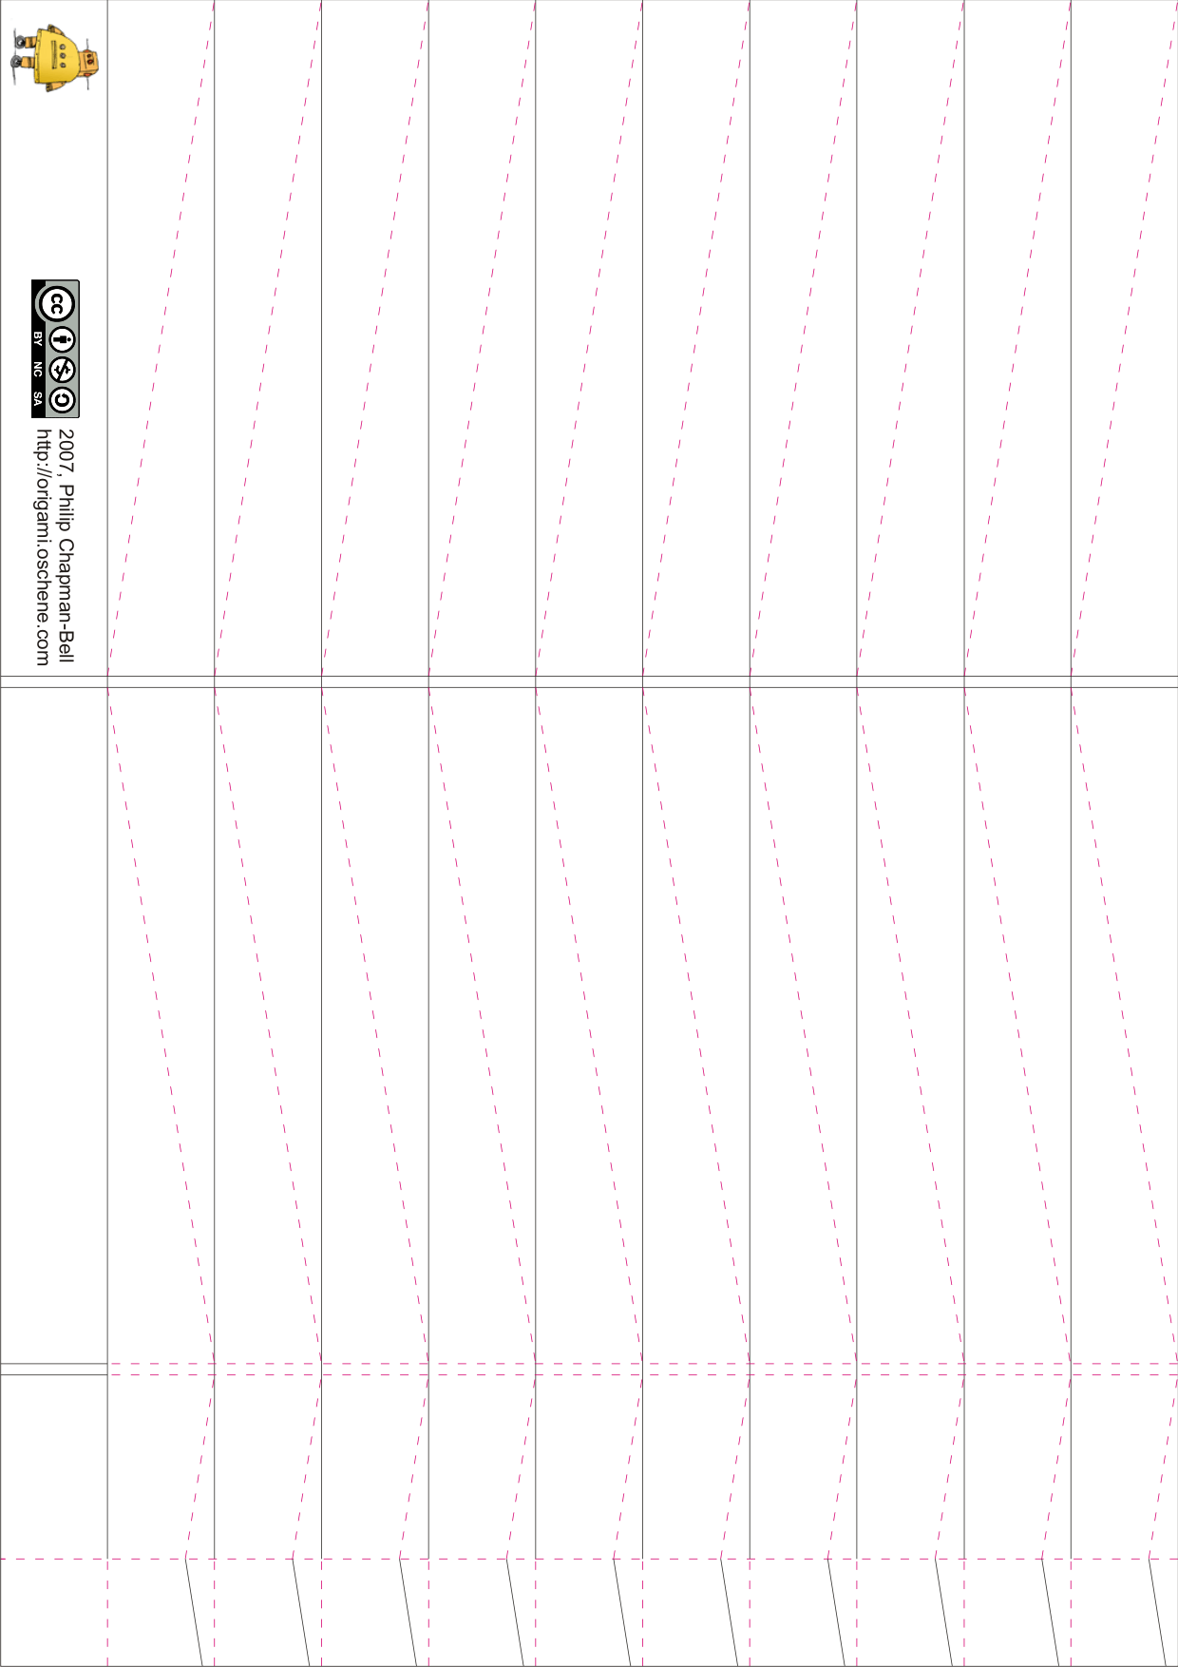
1. She Has Funny Cars
2. Somebody to Love
3. My Best Friend
4. Today
5. Coming Back to Me
6. 3/5 of a Mile in 10 Seconds
7. D.C.B.A.
8. How Do You Feel?
9. Embryonic Journey
10. White Rabbit
11. Plastic Fantastic Lover
Jefferson Airplane – Surrealistic Pillow

