INDUSTRIAL PROJECT REPORT
ON
VOICE OPERATED ROBOT

ABSTRACT
This paper proposes a system where the human voices become a specific key to manipulate a robot.
This project is designed to control a robot by voice commands. An 8051 microcontroller is used together with a Bluetooth module (HC-05) and an LCD display for the desired operation.
The speech command is received and processed by the Bluetooth module (HC-05). When a command for the robot is recognized, then Bluetooth module sends a command message to the robot’s microcontroller. The 8051 microcontroller acts accordingly on the DC motors of the robot which are operated by IC L293D (acts as a motor driver). In achieving this task the controller is loaded with program written using Embedded ‘C’Language.
In this system an android application “BT VOICE CONTROL FOR ARDUINO” (from Google play store and install it) is used to recognize and process human voice which is further converted into text (making use of Google text to speech converter). This text is transferred to the robot using Bluetooth. This text is further processed by the microcontroller to control the robot to move FORWARD, BACKWARD, LEFT, RIGHT accordingly.

ACKNOWLEGDEMENT
The success and final outcomes of this project required a lot of guidance and assistance from many people and we are extremely fortunate to have got this all along the completion of my internship project work. Whatever we have done is only due to such guidance and assistance and we would not forget to thank them.
We respect and thank Mr.Vijay for giving us an opportunity to do the project work in ECIL and providing us all support and guidance which made us complete the project on time, we are extremely great full to him for providing such a nice support and guidance though he had busy schedule managing the company affairs.
We owe our profound gratitude to our project guide Ms.Tejaswi who took keen interest on our project work and guided us all along, till the completion of our project work by providing all the necessary information for developing a good system.
We would not forget to remember to remember Ms.Monika of ECIL for their unlisted encouragement and more over for their timely support and guidance till the completion of our project work.
We heartily thank our internal project guide Mr.Yekambaram for his guidance and suggestion during this project work
We are thankful and fortunate enough to get constant encouragement, support and guidance from all teaching staff of ECIL for helping us in successfully completing our project work.
Also, we would like to extend our sincere regards to all the non-teaching staff of ECIL for their timely support.

TABLOFCONTENTS: PAGE.NO
TITLE PAGE ………………………………………………………………………… 1
- COMPANY CERTIFICATE………………………………………………………….. 1
- ABSTRACT…………………………………………………………………………… 2
- ACKNOWLEDGEMENT……………………………………………………………... 3
- INTRODUCTION……………………………………………………………………… 5
- LITERATURE REVIEW AND PROBLEM STATEMENT………………………… 13
- PROJECT METHODOLOGY………………………………………………………... 15
- RESULTS AND DISCUSSION……………………………………………………..... 17
- CONCLUSION AND FUTURE SCOPE……………………………………………... 19
- BIBLOGRAPHY……………………………………………………………………… 20
- APPENDICES………………………………………………………………………… 20
LIST OF FIGURES AND TABELS:
FIGURES:
- PROJECT MODEL………………………………………………………………..6
- APP IMAGES……………………………………………………………………...9
- MICRO-CONTROLLER…………………………………………………………10
- STEP-DOWN TRANSFORMER………………………………………………....11
- HC-05 BLUETOOTH MODULE…………………………………………………12
- 16X2 LCD DISPLAY……………………………………………………………..12
- L293D MOTOR DRIVER CIRCUIT……………………………………………..13
- STEP-DOWN TRANSFORMER………………………………………………....27
- ATMEL AT 85S92 PIN DIAGRAM……………………………………………...28
- 7805 VOLTAGE REGULATOR………………………………………………….29
- JHD 162A LCD DISPLAY………………………………………………………..30
- L293D MOTOR DRIVER…………………………………………………………31
- XTAL CRYSTAL OSCILLATOR………………………………………………..32
- HC-05 BLUETOOTH MODULE………………………………………………....32
- DC MOTOR……………………………………………………………………….33
- LED………………………………………………………………………………..34
TABLES:
- VOICE CONTROLS…………………………………………………………….17
- COMPONENTS USED………………………………………………………….18
- MOTOR DRIVER FUNCTION TABLE………………………………………..18
- TRANSFORMER DATA SHEET (STEP-DOWN)……………………………..27
- LCD DISPLAY DATA SHEET………………………………………………....30
- L293D MOTOR DRIVER DATA SHEET……………………………………...31

INTRODUCTION
It has always been a dream of human being to create machines that behave like humans. Recognizing the speech and responding accordingly is an important part of this dream. With the improvements of the technology and researches on artificial intelligent, this dream comes true relatively.
In this project, it is aimed to make a contribution to this dream. Controlling the machines and environment with speech makes human life easier and more comfortable. This project is a simple implementation of this approach. A robot is controlled by voice commands. Voice command is taken through a microphone, processed in computer and sent to the robot and finally the robot acts accordingly.
Speech is the most used way of communication for people. We born with the skills of speaking learn it easily during our early childhood and mostly communicate with each other with speech throughout our lives. By the developments of communication technologies in the last era, speech starts to be an important interface for many systems. Instead of using complex different interfaces, speech is easier to communicate with computers.
In this project, it is aimed to control a robot with speech commands. The robot is able to recognize spoken commands to move correctly. To give a direction to robot, first the voice command is send to the ANDROID phone. The android recognizes the command by speech recognition system. And then android converts the voice command to direction command that predefined and recognizable by robot. When the robot gets the direction command, it moves according to spoken command.

  - SPEECH RECOGNIZATION

When we say voice control, the first term to be considered is Speech Recognition i.e. making the system to understand human voice. Speech recognition is a technology where the system understands the words (not its meaning) given through speech.
Speech is an ideal method for robotic control and communication. The speech recognition circuit we will outline, functions independently from the robot’s main intelligence [central processing unit (CPU)]. This is a good thing because it doesn’t take any of the robot’s main CPU processing power for word recognition. The CPU must merely poll the speech circuit’s recognition lines occasionally to check if a command has been issued to the robot. We can even improve upon this by connecting the recognition line to one of the robot’s CPU interrupt lines. By doing this, a recognized word would cause an interrupt, letting the CPU know a recognized word had been spoken. The advantage of using an interrupt is that polling the circuit’s recognition line occasionally would no longer be necessary, further reducing any CPU overhead.
Another advantage to this stand-alone speech-recognition circuit (SRC) is its programmability. You can program and train the SRC to recognize the unique words you want recognized. The SRC can be easily interfaced to the robot’s CPU.

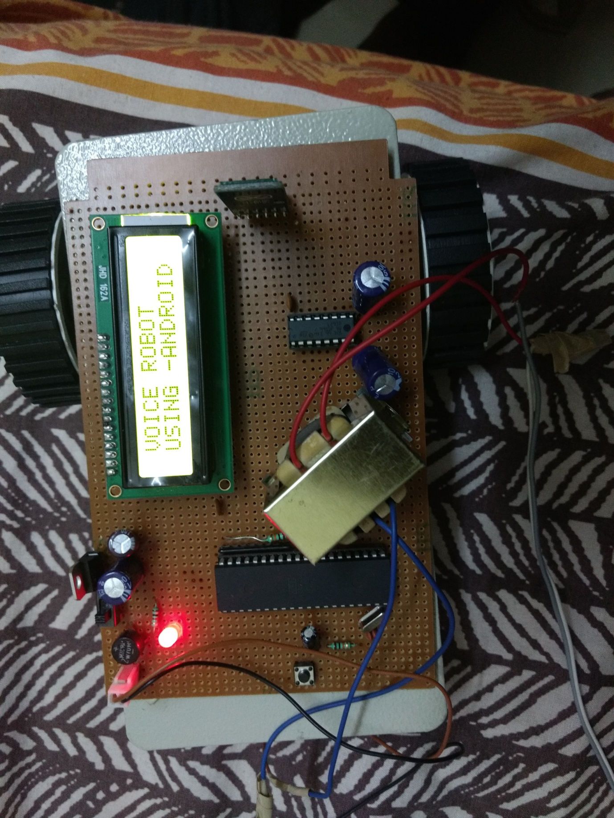

Fig1.1: Project Model

To control and command an appliance (computer, VCR, TV security system, etc.) by speaking to it, will make it easier, while increasing the efficiency and effectiveness of working with that device. At its most basic level speech recognition allows the user to perform parallel tasks, (i.e. hands and eyes are busy elsewhere) while continuing to work with the computer or appliance.
Robotics is an evolving technology. There are many approaches to building robots, and no one can be sure which method or technology will be used 100 years from now. Like biological systems, robotics is evolving following the Darwinian model of survival of the fittest. Suppose you want to control a menu driven system. What is the most striking property that you can think of? Well the first thought that came to our mind is that the range of inputs in a menu driven system is limited. In fact, by using a menu all we are doing is limiting the input domain space. Now, this is one characteristic which can be very useful in implementing the menu in standalone systems. For example think of the pine menu or a washing machine menu. How many distinct commands do they require?

1.2 WHY BUILD ROBOTS?

Robots are indispensable in many manufacturing industries. The reason is that the cost per hour to operate a robot is a fraction of the cost of the human labour needed to perform the same function. More than this, once programmed, robots repeatedly perform functions with a high accuracy that surpasses that of the most experienced human operator. Human operators are, however, far more versatile.
Humans can switch job tasks easily. Robots are built and programmed to be job specific. You wouldn’t be able to program a welding robot to start counting parts in a bin. Today’s most advanced industrial robots will soon become “dinosaurs.” Robots are in the infancy stage of their evolution.
As robots evolve, they will become more versatile, emulating the human capacity and ability to switch job tasks easily. While the personal computer has made an indelible mark on society, the personal robot hasn’t made an appearance. Obviously there’s more to a personal robot than a personal computer. Robots require a combination of elements to be effective: sophistication of intelligence, movement, mobility, navigation, and purpose. Without risking human life or limb, robots can replace humans in some hazardous duty service. Robots can work in all types of polluted environments, chemical as well as nuclear. They can work in environments so hazardous that an unprotected human would quickly die. As strange as it might seem, there really is no standard definition for a robot. However, there are some essential characteristics that a robot must have and this might help you to decide what is and what not a robot is. It will also help you to decide what features you will need to build into a machine before it can count as a robot.

A robot has these essential characteristics:
- SENSING

First of all your robot would have to be able to sense its surroundings. It would do this in ways that are not similar to the way that you sense your surroundings. Giving your robot sensors: light sensors (eyes), touch and pressure sensors (hands), chemical sensors (nose), hearing and sonar sensors (ears), and taste sensors (tongue) will give your robot awareness of its environment.

- MOVEMENT
A robot needs to be able to move around its environment. Whether rolling on wheels, walking on legs or propelling by thrusters a robot needs to be able to move. To count as a robot either the whole robot moves, like the Sojourner or just parts of the robot moves, like the Canada Arm.

- ENERGY

A robot needs to be able to power itself. A robot might be solar powered, electrically powered, battery powered. The way your robot gets its energy will depend on what your robot needs to do.

- INTELLIGENCE
A robot needs some kind of "smarts." This is where programming enters the pictures. A programmer is the person who gives the robot its 'smarts.' The robot will have to have some way to receive the program so that it knows what it is to do.
Well it is a system that contains sensors, control systems, manipulators, power supplies and software all working together to perform a task. Designing, building, programming and testing robots is a combination of physics, mechanical engineering, electrical engineering, structural engineering, mathematics and computing. In some cases biology, medicine, chemistry might also be involved.
A study of robotics means that students are actively engaged with all of these disciplines in a deeply problem-posing problem-solving environment.

1.3 ANDROID
Android is an operating system based on the Linux kernel, and designed primarily for touch screen mobile devices such as smart phones and table computers. Initially developed by Android, Inc., which Google backed financially and later bought in 2005, Android was unveiled in 2007 along with the founding of the Open Handset Alliance a consortium of hardware, software, and telecommunication companies devoted to advancing open standards for mobile devices.
The first publicly available smart phone running Android, the HTC Dream, was released on October 22, 2008. The user interface of Android is based on direct manipulation, using touch inputs that loosely correspond to real-world actions, like swiping, tapping, pinching and reverse pinching to manipulate on-screen objects.
Internal hardware such as accelerometers, gyroscopes and proximity sensors are used by some applications to respond to additional user actions, for example adjusting the screen from portrait to landscape depending on how the device is oriented. Android allows users to customize their home screens with shortcuts to applications and widgets, which allow users to display live content, such as emails and weather information, directly on the home screen. Applications can further send notifications to the user to inform them of relevant information, such as new emails and text messages.
1.4. ANDROID MEET ROBOT
It is the APP which is used in our project to control or commanding the robot.
Uses android mobiles internal voice recognition to pass voice commands to your robot Pairs with Bluetooth Serial Modules and sends in the recognized voice as a string.
For example if you say Hello the android phone will return a sting *Hello# to your Bluetooth module *and # indicate the start and stop bits Can Be used with any micro controller which can handle strings.
Examples Platforms: Arduino, ARM, PICAXE, MSP430, 8051 based and many other processors and controllers.

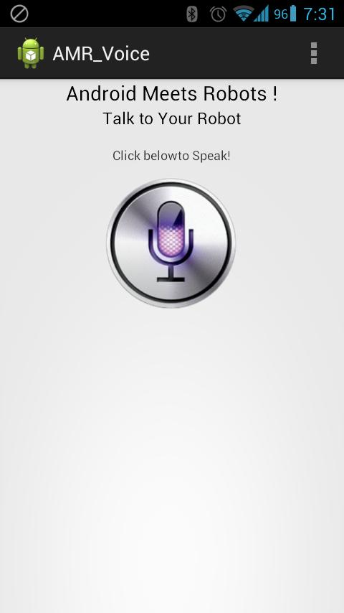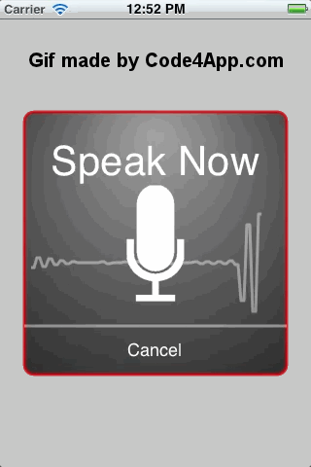

Fig 1.2: App images

1.5 BLOCK DIAGRAM

Block diagram is a diagram of a system in which the principal parts or functions are represented by blocks connected by lines that show the relationships of the blocks. They are heavily used in the engineering world in hardware design, electronic and software design and process flow diagrams.
Block diagrams rely on the principle of the black box where the contents are hidden from view either to avoid being distracted by the details or because the details are not known. We know what goes in, we know what goes out, but we can't see how the box does its work.

Fig 1.3: Block diagram of voice control robot
The above diagram shows the important blocks involves in this project. There are mainly five blocks in this project.
There are:
- Microcontroller
- Step-down transformer
- Bluetooth Module
- LCD
- Driver

1.5.1 MICROCONTROLLER
A microcontroller (sometimes abbreviated µC, uC or MCU) is a small computer on a single integrated circuit containing a processor core, memory, and programmable input/output peripherals. Program memory in the form of NOR flash or OTP ROM is also often included on chip, as well as a typically small amount of RAM. Microcontrollers are designed for embedded applications, in contrast to the microprocessors used in personal computers or other general purpose applications.
Microcontrollers are used in automatically controlled products and devices, such as automobile engine control systems, implantable medical devices, remote controls, office machines, appliances, power tools, toys and other embedded systems. By reducing the size and cost compared to a design that uses a separate microprocessor, memory, and input/output devices, microcontrollers make it economical to digitally control even more devices and processes. Mixed signal microcontrollers are common, integrating analog components needed to control non-digital electronic systems.
Some microcontrollers may use 4-bit words and operate at clock rate frequencies as low as 4 kHz, for low power consumption (single-digit milli watts or microwatts). They will generally have the ability to retain functionality while waiting for an event such as a button press or other interrupt; power consumption while sleeping (CPU clock and most peripherals off) may be just Nano watts, making many of them well suited for long lasting battery applications. Other microcontrollers may serve performance-critical roles, where they may need to act more like a digital signal processor (DSP), with higher clock speeds and power consumption.
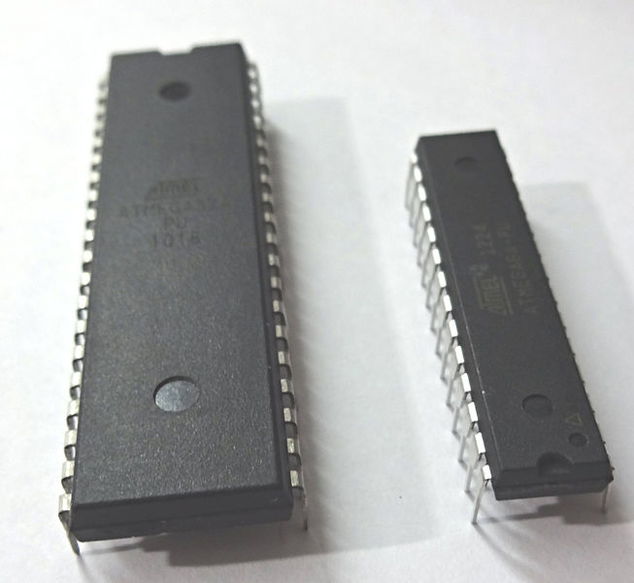
Fig 1.3: Micro controller

In this project we used AT89S52 µC. The AT89S52 is a low-power, high-performance CMOS 8-bitmicrocontroller with 8K bytes of in-system programmable Flash memory. The device is manufactured using Atmel’s high-density non-volatile memory technology and is compatible with the industry-standard 80C51 instruction set and pin out. In the chapter 2 we discussed in detailed about microcontroller.

1.5.2 STEP DOWN TRANSFORMER:

The transformer is the first part of the power supply, but you need more to get DC.The varying input voltage of the transformer creates an equally varying magnetic field in the metal core. This magnetic field in turn creates an, again varying, voltage on the output. Both input and output voltage is sine waves. It's called AC (alternating current) because the sign of the output voltage changes continuously, 100 or 120 times per second, depending on the country.
You rectify this AC voltage to get rid of the sign changes; one pin will always be positive with respect to the other one.
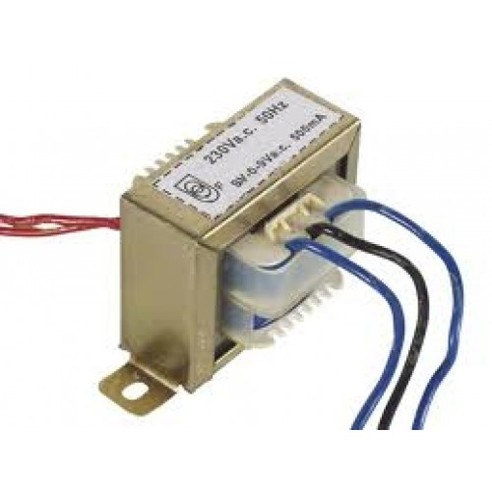
1.4 Step down transformer
The one thing which remains to be done now is to flatten the curve, get rid of the ripples. This is done by a capacitor. You now have a DC (direct current) voltage which is already usable for a number of situations. This voltage, however, may still show slight variations, which may be unwanted. To get rid of those you follow the capacitor by a voltage regulator.
1.5.3 BLUETOOTH MODULE
A Bluetooth module is usually a hardware component that provides a wireless product to work with the computer; or in some cases, the Bluetooth may be an accessory or peripheral, or a wireless headphone or other product (such as cell phones can use.). If the computer (is this computer related?) has hardware support to use Bluetooth products and connections, then whatever it is you are trying to download and use, may work. There are component Bluetooth wireless modules with a USB plug on them to add this BT to computers that did not have it built-in. Some of these modules may require drivers, but usually Mac OS X has drivers built into the system to support several products. In the chapter 4 we discussed in detailed about Bluetooth module. The below figure shows the model of Bluetooth module,
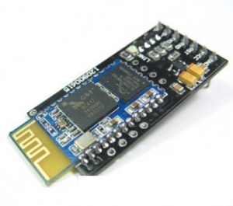
Fig 1.5: HC-05 Bluetooth module
These small size Bluetooth TTL transceiver modules are designed for serial communication (SPP - serial port profile). It allows your target device to either send or receive TTL data via Bluetooth technology without connecting a serial cable to your computer. The modules with the HC-03 and HC-05 firmware are the Master and Slave integrated Bluetooth serial modules with firmware which allows you to modify master and slave mode at any time. HC-03 is industrial grade products, HC-05 are commercial grade products.
The modules with the HC-04 and HC-06 firmware are the modules which are factory set to be Master or Slave modules. Master and slave mode cannot be switched from the factory setting. HC-04 is an industrial grade product; HC-06 is a commercial grade product. The modules with the HC-09 firmware are replacements for the HC-06 and HC-07 modules.
1.5.4 LCD
These LCD screens are limited to monochrome text and are often used in copiers, fax machines, laser printers, industrial test equipment, networking equipment such as routers and storage devices. The screens come in a small number of standard configurations. Common sizes are 8x1 (one row of eight characters), 16×2, 20×2 and 20×4. Larger custom sizes are made with 32, 40 and 80 characters and with 1, 2, 4 or 8 lines. The most commonly manufactured larger configuration is 40×4characters, which requires two individually addressable HD44780 controllers with expansion chips as a single HD44780 chip can only address up to 80 characters. A common smaller size is 16×2, and this size is readily available as surplus stock for hobbyist and prototyping work. Character LCDs can come with or without backlights, which may be LED, fluorescent, or electroluminescent.
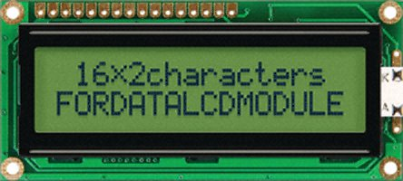
Fig 1.6: 16X2 LCD
1.5.5 DRIVER
In electronics, a driver is an electrical circuit or other electronic component used to control another circuit or other component, such as a high-power transistor.
They are usually used to regulate current flowing through a circuit or is used to control the other factors such as other components, some devices in the circuit. The term is often used, for example, for a specialized integrated circuit that controls high-power switches in switched-mode power-converters. An amplifier can also be considered a driver for loudspeakers, or a constant voltage circuit that keeps an attached component operating within a broad range of input voltages. Typically the driver stage(s) of a circuit requires different characteristics to other circuit stages. For example in a transistor power amplifier, typically the driver circuit requires current gain, often the ability to discharge the following transistor bases rapidly, and low output impedance to avoid or minimize distortion.

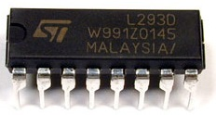
Fig 1.7: L293D Driver circuit

The L293D is a popular motor driver IC that is usable from 6 to12V, at up to 1A total output current. By itself, the IC is somewhat difficult to wire and use, but the Compact L293D Motor Driver makes it much more convenient to use.
Board Special Features
- Four motor direction indicator LEDS
- Schottky EMF-protection diodes
- Socket pin connectors for easy logic interfacing
- Enable pins are user accessible.

2.1 LITERATURE REVIEW:
Speech Recognition research has been ongoing for more than 80 years. The project ‘voice operated robot’ is mainly based on speech recognition. When we say voice control, the first term to be considered is Speech Recognition i.e., making the system to understand human voice. Generally these kinds of systems are known as Speech Controlled Automation Systems (SCAS). Our system will be a prototype of the same.
There were many projects based on the voice recognition in which whoever will be the user, the device recognizes the speech and do accordingly to the user.
For example: Automatic opening of doors and windows, when a voice command is given which uses the same components like micro-controller and DC motors that can be used in Home security systems . To control and command an appliance (computer, VCR, TV security system, etc.) by speaking to it, will make it easier, while increasing the efficiency and effectiveness of working with that device .At its most basic level speech recognition allows the user to perform parallel tasks, (i.e. hands and eyes are busy elsewhere) while continuing to work with the computer or appliance.
By 2001, computer speech recognition had reached 80% accuracy and no further progress was reported till 2010.
The process of speech recognition took place even in IT industry also, in which great companies had taken a part:
In 2010, Google added “personalized recognition” to Voice Search on Android phones, so that the software could record users’ voice searches and act according to the user. Like Google’s Voice Search, the ‘I Phone Siri’ relies on human speech recognition. It draws on its knowledge about the speaker to generate a contextual reply and responds to voice input.
2.2 PROBLEM STATEMENT:
1. To recognize a word spoken by the user
2. To display the correctly recognized word on a character LCD.
The robot consists of 5 sections: 1. Power supply system
2. Analog to digital converter
3. 8051 micro-controller
4. An LCD display
5. Bluetooth module (HC-05)
6. Motor driver section

Our contribution for the project is to ensure or realize people the necessity of the smart living. Previously the ‘voice operated robot’ interfaces a voice recognition module (sensor) which is more expensive and also makes the circuit complex. Instead of interfacing voice recognition module, we used a Bluetooth (HC-05) which makes the circuit complexity less and works accurately. It is completely a new model which is based on wireless communication which became common mow-a-days.

The range of Bluetooth is greater (10 meters/30 feet) than that of voice recognition module (5-6 meters) which is an additional advantage to the circuit. As the Bluetooth communication is wireless, it became a new technological strategy that anyone can use this idea anywhere even at their homes. This idea became a new strategy even in large scale industries also in which they make their robots work based on their voice commands by performing multi-tasking (parallel tasks) by the help of interfacing the micro-controller with motors depending on the usage.

In large scale industries like mining etc., without risking human life or limb, robots can replace humans in some hazardous duty service. Robots can work in all types of polluted environments, chemical as well as nuclear. They can work in environments so hazardous that an unprotected human would quickly die which has become a new strategy.

METHODOLOGY
In this proposed system a speech recognition module is not required to recognize human voice to control robot. In this system an android application is used to recognize and process human voice which is further converted into text (making use of google speech to text converter). This text is transferred to the robot using Bluetooth. This text is further processed by the microcontroller to control the robot accordingly. The purpose of this research is to provide simpler robot‟ hardware architecture but with powerful computational platforms so that robot’s designer can focus on their research and tests instead of Bluetooth connection infrastructure. This simple architecture is also useful for educational robotics, because students can build their own robots with low cost and use them as platform for experiments in several courses. Common control architectures: The following list shows typical robot control architecture: A. AT89S52 the AT89S52 is a low-power, high performance CMOS 8- bit microcontroller with 8k bytes of in-system programmable flash memory. The device is manufactured using Atmel’s high-density non-volatile memory technology and is compatible with the industry-standard 80C51 instruction set and pin out. The Atmel AT89S52 is a powerful microcontroller which provides a highly flexible and cost-effective solution to many embedded control applications. The AT89S52 Provides the following standard features: 8K bytes of flash, 256 bytes of RAM, 32 I/O Ines, Watchdog timer, two data pointers, three 16bit timer/counters, a six-vector two-level interrupt architecture, a full duplex serial port, on-chip oscillator, and clock circuitry. The AT89S52 is designed with static logic for operation down to zero frequency and supports two software selectable power saving modes. The power down mode saves the RAM contents but freezes the oscillator, disabling all other chip function until the next interrupt or hardware reset.

A. HC Serial Bluetooth
HC Serial Bluetooth product consists of Bluetooth serial interface module and Bluetooth adapter. Bluetooth serial module is used for converting serial port to Bluetooth. This module has two modes: master and slaver device. The device named after even number is defined to be master or slaver when out of factory and can’t changed to the other mode. But for the device named after odd number, users can set the work mode (master or slaver) of the device by AT commands. HC-06 Specifically includes: Master device: HC-06-M, M=Master Slaver device: HC06-S, S=Slaver The main function of Bluetooth serial module is replacing the serial port line, such as: One connects to Bluetooth master device while the other one connect to slaver device. Their connection can be built once the pair is made. This Bluetooth connection is equivalently liked to a serial port line connection including RXD, TXD signals. And they can communicate with each other. 1. When MCU has Bluetooth salve module, it can communicate with Bluetooth adapter of computer and smart phones. 2. The Bluetooth devices in the market mostly are salve devices, such as Bluetooth printer, Bluetooth GPS. So we can use master module to make pair and communicate with them. 3. Bluetooth serial module’s operation doesn’t need drive, and can communicate with the other Bluetooth device. But communication between two Bluetooth modules require at two conditions: i) the communication must be between master and slave. ii) The password must be correct. Here are the main factory parameter of HC-05 and HC-06. Pay attention to the difference: Table 1.1:Comparision of 2 modules HC-05 HC-06 Master and Slave mode can be Switched Master and Slave mode can’t be switched Bluetooth Name: HC-05 Bluetooth Name: HC-06 Password: 1234 Password: 1234

B. L293D
The L293 and L293D are quadruple high-current half H-drivers. The L293 IS designed to provide bidirectional drive currents of up to 1A at voltage from 4.5V to 36V. The L293D is designed to provide bidirectional drive currents of up to 600-MA at voltages from 4.5V to 36V. Both devices are designed to drive inductive loads such as relays, solenoids, dc and bipolar stepping motors, as well as other high-current/high voltage loads in positive-supply applications. On the L293D, external high-speed output clamp diodes should be used for inductive transient suppression. A Vcc1 terminal, separate from Vcc2, is provided for the logic inputs to minimize device power dissipation.
C. DC MOTOR
Almost every mechanical movement that we see around us is accomplished by an electric motor. Electric machines are means of converting energy. Motors take electrical energy and produce mechanical energy. Electric motor is used to power hundreds of devices we use in everyday life. An example of small motor applications includes motors used in automobiles, robot, hand power tools and food blenders. Micro-machines are electric machines with parts the size of red blood cells and find many applications in medicine. E. UART Universal asynchronous receiver/ transmitter is usually an individual integrated circuit used for serial communications over a computer or peripheral device serial port. UART are now commonly included in microcontrollers. A dual UART combines two UARTS into a single chip. Many modern ICs come with a UART that can also communicate synchronously; these devices are called UART.
3. RESULT AND DISCUSSION

Voice Operated Robot, which usually works on human-voice commands. The main source for this robot is VOICE, which plays an important role in functioning of the robot. We can give commands like FRONT, BACK, LEFT, RIGHT, and STOP to control the motion of the robot.
Robot contains a Bluetooth module which takes the command from a mobile phone and converts the voice signal to electrical signal and makes the robot to run according to your voice in just 1.3 sec which is the easiest and fastest way to control the robot rather than switch operation. This works when you have proper network coverage of 3G/4G.
The main observation in this robot is NOISE, which is the major issue for voice robots. The robot can work instantly when there is low noise. When the robot is operated in crowded areas, the voice command which you give will contain high noise levels, which affect the functioning of the Bluetooth module, so the robot should be operated in low noise regions.
The robot uses a Bluetooth module for receiving voice commands, where the module has a range limit of about 10-meters and it is a wired device so the distance it covers it depends upon the length of the wire used.

3.1 DESCRIPTIVE STATISTICS

VOICE-CONTROLS
INPUT | OUTPUT
FRONT  BACK  LEFT  RIGHT  STOP | MOVES FORWARD  MOVES BACKWARD  TURNS LEFT  TURNS RIGHT  STOP

COMPONENTS USED

- 12V TRANSFORMER
- ATMEL AT89S52 microcontroller
- JHD 162A LCD display
- 7805 Voltage regulator
- XTAL KDS11.0592 CRYSTAL OSCILLATOR
- 1000uf, capacitor(3)
- 10uf capacitor
- 100uf capacitor
- 0.01uf capacitors(2)
- L293D Motor driver
- HC-05 Bluetooth-module
- 100RPM DC-Motors
- LED

3.2 MOTOR DRIVER FUNCTION TABLE

MOTOR-INPUT | ENABLE | MOTOR-OUTPUT
HIGH  LOW  X | HIGH  LOW  HIGH | HIGH  LOW  Z(IMPEDANCE)

3.3 ECNOMETRIC MODEL:
The VOICE CONTROL ROBOT is an economical model, because it uses Bluetooth module instead of using voice recognition module. The voice recognition module is on expensive side where the Bluetooth module will cost lesser than the voice module.
So these types of Bluetooth controlled robots can be used in large scale industries and also can be used for domestic purposes.

4. CONCLUSION
The objective of the paper is to realize the smart living. It is concluded that smart living will gradually turn in to reality that consumer can control their home remotely and wirelessly.

4.1 FUTURE SCOPE
The future scope of this project can be enhanced using DTMF technology. Using this technology we can control the robotic vehicle by using cell phone. This technology has an advantage over long communication range as compared to RF technology. The purpose of such robotic system is to help people with motor disabilities in controlling different widgets in daily life using mobile phone. The proposed idea can be expanded to control almost any device with Bluetooth receiver. In future we use a secured wireless channel using encryption and decryption. A highly reliable and easy system to accomplish a purpose design specific task such as distribution of medicine and food to the bed ridden patients specially in infected & inaccessible areas of the hospitals and medical Centre have been reported. The on-board intelligence helps providing situational awareness a basic requirement of the system to be operated by voice / tele confined for ascertaining a majority of other tasks in open loop environment. The operation by voice command could best be used for handicapped.
The outcome of the thesis is a simple robot which is controlled by a smart android phone& also receives the voice commands. This thesis aims to provide simple guidelines for people interested in building robots. As mentioned earlier, the project has been carried out several times and the aim of this thesis is to familiarize the students with fundamentals of Arduino and Android to build anything possible. Although the thesis projects very little about the robot’s use in real world, but with the help of guidelines and the abundance of resources.

BIBLIOGRAPHY
[1] Android Developers Guide. Android Architecture. [Online] 2013. URL:http://.android.com/about/versions/index.html.
[2] Heidi Monson (1999) Bluetooth technology and implementations, John Wiley & Sons.
[3] HC-06bluetoothmodule http://www.micro4you.com/files/ElecFreaks/Bluetooth%20HC06.pdf
[4] Arduino, ios, android and technology tit bits, http:// sree.cc/Google/android/using-Bluetooth-in-android.
[5] Smart phones android operated robot, http://www.sooxmatechnologies.com [6] Bluetooth based android phone/tablet controlled robot, http://www.robokits.co.in and http://www.robokitsworld.com.
[7] “Android Mobile Phone Controlled Bluetooth Robot. Using 8051 Microcontroller” proceedings of, July 2014 www.ijser.in ISSN (Online): 2347‐3878, Volume 2 Issue 7.
Appendices:
CODE

/*===========================================*/
/*------radio freq id programming------------*/
/*------PH:89C51RD+,08/07/08-----------------*/
/*===========================================*/

LCD_DPort EQU P0

LCD_Rs EQU P1.5
LCD_Rw EQU P1.6
LCD_En EQU P1.7

DELAY1 DATA 30h
DELAY2 DATA 31h
DELAY3 DATA 32h

FDispRFID Bit 01h

/*-------------------------------------*/
org 00h
ljmp Power_on

org 23h
ljmp serial_ISR
/*-------------------------------------*/
org 100h
Power_on:
mov R0,#00h
clr A
LclearNxtRAM:
mov @R0,a
inc R0
cjne R0,#0FFh,LclearNxtRAM
mov R0,#00h
mov P2,#00h

acall LCD_Init
mov TMOD,#20h
mov TH1,#0FDh
mov TL1,#0FDh
mov SCON,#50h
mov IE,#90h
setb TR1

acall welcomedata
mov R0,#70h
mov R2,#4
mov R3,#00h
setb EA
mov P2,#00h
/*-------------------------------------*/
MainLoop:
jb FDispRFID,RFIDLoop
jmp MainLoop
/*-------------------------------------*/
RFIDLoop: Ljmp RFIDDATA
/*-------------------------------------*/
RFIDDATA:
clr FDispRFID

mov R0,#70h
mov R2,#4

mov dptr,#CARDNUM0
call Compare
cjne R3,#01h,Check_BWD
call delay1sec
acall welcomedata
mov P2,#0AAh
call delay1sec
mov R0,#70h
mov R2,#4
mov R3,#00h
jmp MainLoop

Check_BWD:
mov dptr,#CARDNUM1
call Compare
cjne R3,#01h,Check_LFT
mov P2,#55h
call delay1sec
acall welcomedata
mov R0,#70h
mov R2,#4
mov R3,#00h
jmp MainLoop

Check_LFT:
mov dptr,#CARDNUM2
call Compare
cjne R3,#01h,Check_RT
mov P2,#88h
call delay1sec
acall welcomedata
mov R0,#70h
mov R2,#4
mov R3,#00h
jmp MainLoop
Check_RT:
mov dptr,#CARDNUM3
call Compare
cjne R3,#01h,Check_ST
mov P2,#22h
call delay1sec
acall welcomedata
mov R0,#70h
mov R2,#4
mov R3,#00h
jmp MainLoop
Check_ST:
mov dptr,#CARDNUM4
call Compare
cjne R3,#01h,EXIT
mov P2,#00h
call delay1sec
acall welcomedata
mov R0,#70h
mov R2,#4
mov R3,#00h
jmp MainLoop
EXIT:
jmp MainLoop

CARDNUM0: DB "stat"
CARDNUM1: DB "back"
CARDNUM2: DB "left"
CARDNUM3: DB "righ"
CARDNUM4: DB "stop"

/*-------------------------------------*/
Compare:
Card1_ChK:
clr a
movc a,@a+dptr
mov b,a
mov a,@R0
cjne a,b,Next_ChK
inc R0
inc dptr
djnz R2,Card1_ChK
inc R3
ret
Next_ChK:
mov R0,#70h
mov R2,#4
ret
/*-------------------------------------*/
serial_ISR:
push Acc
push DPH
push DPL
jb RI,RX_Service
jb TI,TX_Service
pop DPL
pop DPH
pop Acc
reti

RX_Service:
clr RI
mov a,sbuf
mov @R0,a
call delay20ms
call delay20ms
call delay20ms
call delay20ms
inc R0
djnz R2,End_isr

setb FDispRFID
ljmp End_isr
TX_Service:
clr TI
ljmp End_isr

End_isr:
pop DPL
pop DPH
pop Acc
reti

/****************************************/
/*-----welcome data programming---------*/
/****************************************/
welcomedata:
call lcdclear
call displine1
mov dptr,#mydata
call DISPDATA

call displine2
mov dptr,#mydata0
call DISPDATA

ret

mydata : DB" VOICE CONTROLLED",0
mydata0: DB"ROBOT USING ANDRIOD",0
/********************************************/
/*---LCD initialization program------------*/
/******************************************/
LCD_Init:
mov a,#30h
call LCD_CMND_OUT

mov a,#38h
call LCD_CMND_OUT

mov a,#06h
call LCD_CMND_OUT

mov a,#01h
call LCD_CMND_OUT

mov a,#0ch
call LCD_CMND_OUT

RET
/*******************************************/
/*-------lcd command programming-----------*/
/*******************************************/
LCD_CMND_OUT:
call lcd_busy
mov LCD_DPort,a
clr LCD_Rs
clr LCD_Rw
setb LCD_En
nop
nop
clr LCD_En
RET
/****************************************/
/*-------lcd data programming-----------*/
/****************************************/
LCD_DATA_OUT:
call lcd_busy
mov LCD_DPort,a
setb LCD_Rs
clr LCD_Rw
setb LCD_En
nop
clr LCD_En
RET
/****************************************/
/*----------busy check programming------*/
/****************************************/
lcd_busy:
mov LCD_DPort,#0ffh
CLR LCD_Rs
SETB LCD_Rw
AGAIN1:
CLR LCD_EN
NOP
NOP
SETB LCD_EN
JB p0.7,AGAIN1
RET
/***************************************/
/*-----Display the string&send---------*/
/***************************************/
DISPDATA:
Next_Char:
clr a
movc a,@a+dptr
jz End_Str
mov Sbuf,a
call delay20ms
call LCD_DATA_OUT
inc dptr
jmp Next_char
End_Str:
RET
/*-------------------------------------*/
DISP_ENTER:
mov a,#0Dh
mov SBUF,a
call delay20ms

mov a,#0Ah
mov SBUF,a
call delay20ms
ret
/***************************************/
/*---------display routine-------------*/
/***************************************/
lcdclear:
mov a,#01h
call LCD_CMND_OUT
ret
displine1:
mov a,#80h
call LCD_CMND_OUT
ret
displine2:
mov a,#0c0h
call LCD_CMND_OUT
ret
displine3:
mov a,#94h
call LCD_CMND_OUT
ret
displine3A:
mov a,#9dh
call LCD_CMND_OUT
ret
displine4:
mov a,#0d4h
call LCD_CMND_OUT
ret
displine4A:
mov a,#0ddh
call LCD_CMND_OUT
ret
/******************************************/
/*-------Delay routine-------------------*/
/****************************************/
delay1sec:
mov DELAY1,#10
wait2: mov DELAY2,#200
wait1: mov DELAY3,#250
wait: djnz DELAY3,wait
djnz DELAY2,wait1
djnz DELAY1,wait2
ret
delay500ms:
mov DELAY1,#5
wait22: mov DELAY2,#183
wait12: mov DELAY3,#250
wait0: djnz DELAY3,wait0
djnz DELAY2,wait12
djnz DELAY1,wait22
ret
delay20ms:
mov DELAY2,#40
wait31: mov DELAY3,#250
wait3: djnz DELAY3,wait3
djnz DELAY2,wait31
ret
delay:
mov DELAY1,#255
same: djnz DELAY1,same
ret

end

Background math:
We were both interested in building some kind of robot. We researched projects that had been done in the field of robotics and there existed a line follower robot, and sensor robots but none of them used speech to control a robot. In the digital world, it would be cool to make a robot which obeys human speech commands and performs errands.

Speech Analysis
In order to analyze speech, we needed to look at the frequency content of the detected word. To do this we used several 4th order Chebyshev band pass filters. To create 4th order filters, we cascaded two second order filters using the following "Direct Form II Transposed" implementation of a difference equations.

SPECIFICATIONS OF HARDWARE COMPONENTS
- 12V TRANSFORMER

DATA SHEET:
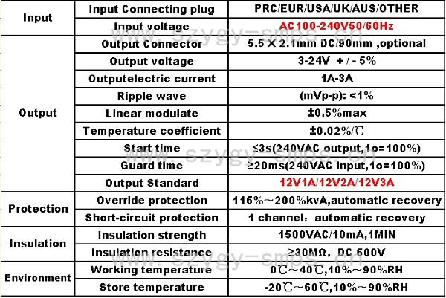
2. ATMEL AT89S52:
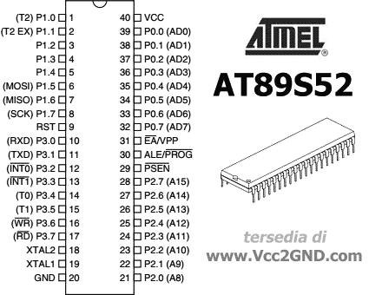
SPECIFICATIONS:

Features
- 8 K Bytes of In-System Programmable (ISP) Flash Memory – Endurance: 10,000 Write/Erase Cycles
- 4.0 V to 5.5V Operating Range
- Fully Static Operation: 0 Hz to 33 MHz
- Three-level Program Memory Lock
- 256 x 8-bit Internal RAM
- 32 Programmable I/O Lines
- Three 16-bit Timer/Counters
- Eight Interrupt Sources
- Full Duplex UART Serial Channel
- Low-power Idle and Power-down Modes
- Interrupt Recovery from Power-down Mode
- Watchdog Timer
- Dual data pointer
- Power-off Flag
- Fast Programming Time
- Flexible ISP Programming (Byte and Page Mode)

7805 VOLTAGE REGULATOR SPECIFICATIONS:

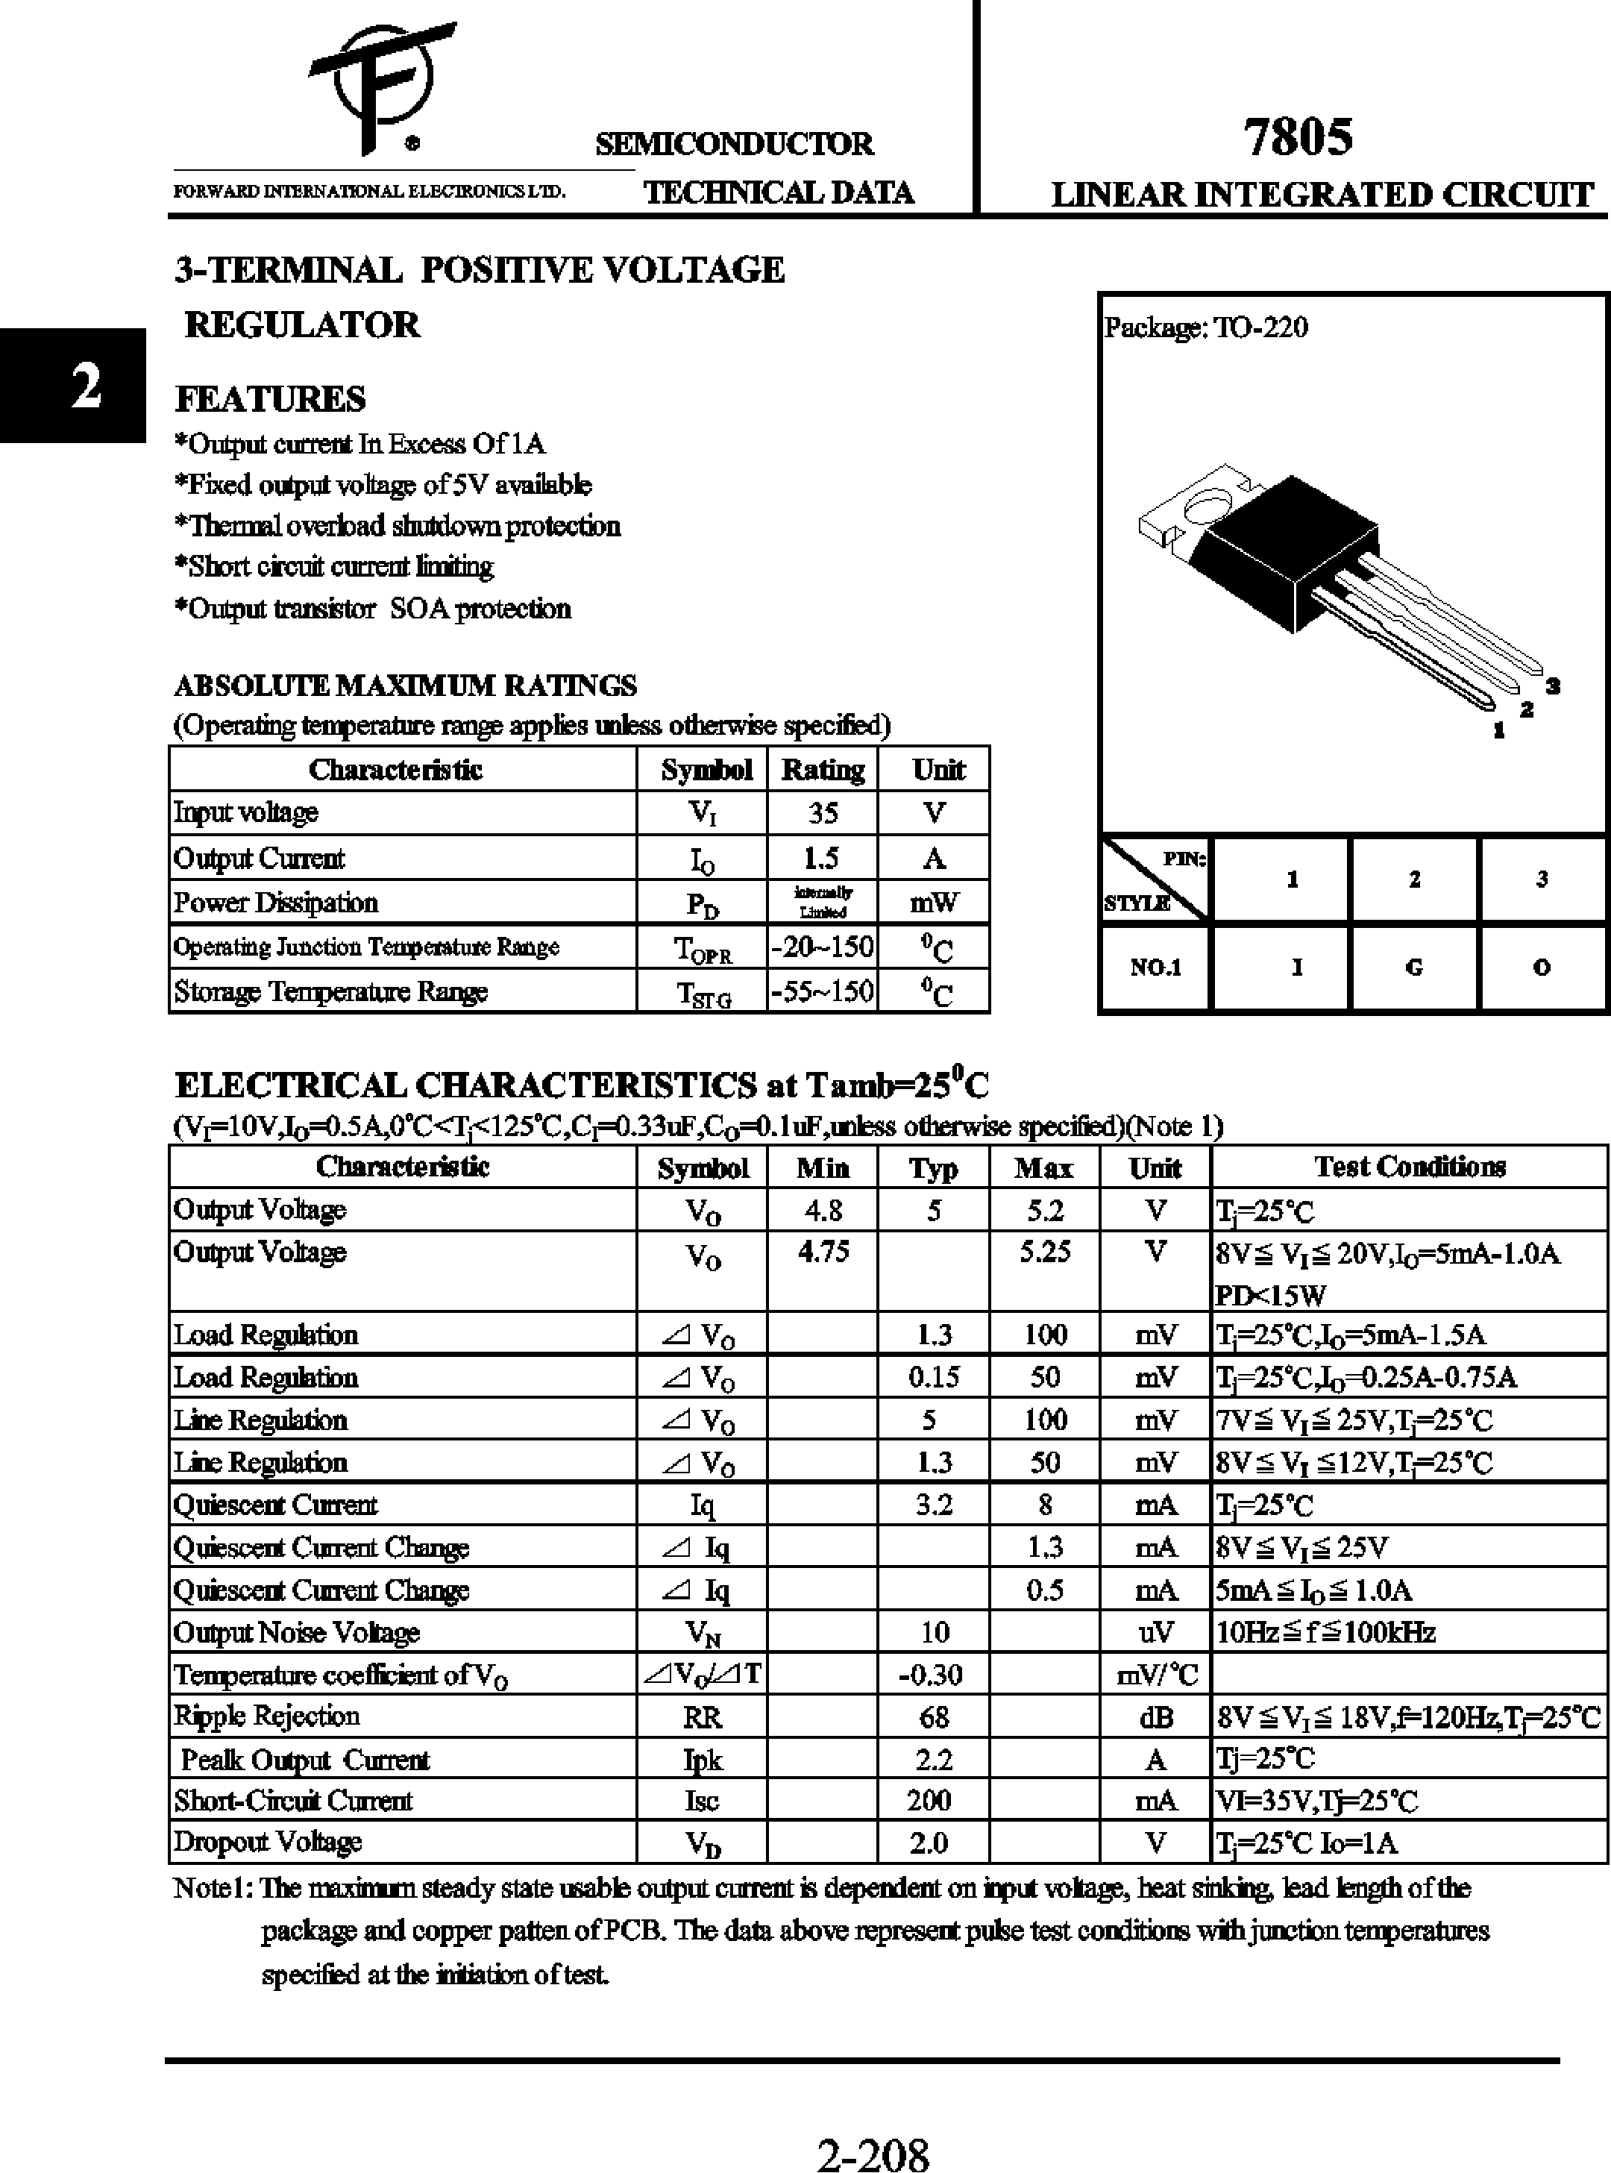

JHD 162A LCD DISPLAY
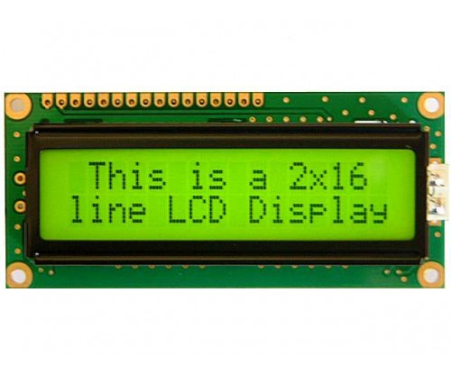
SPECIFICATIONS

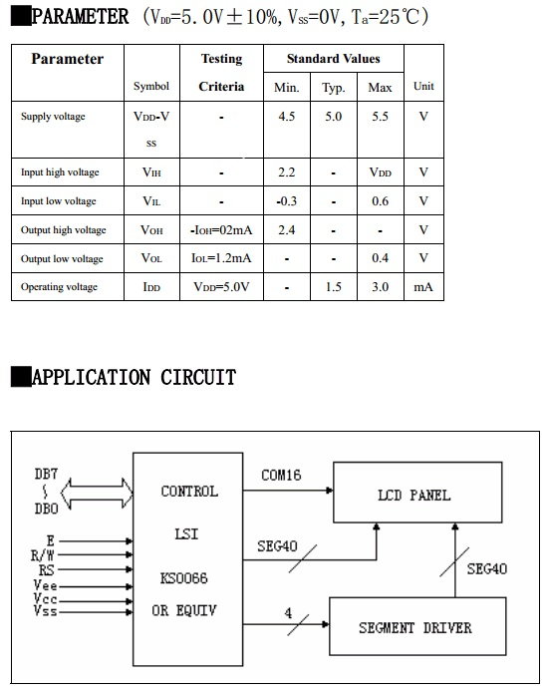

MOTOR DRIVER L293D MOTORL:
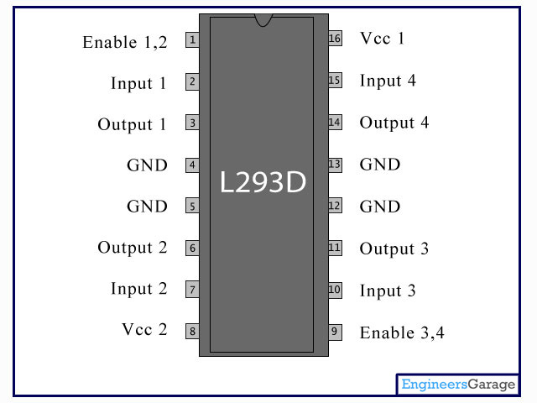

DATA SHEET
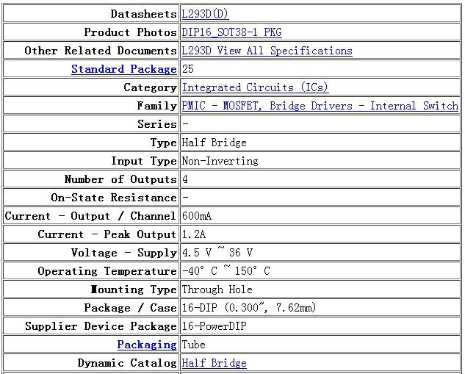

XTAL (CRYSTAL OSCILLATOR):

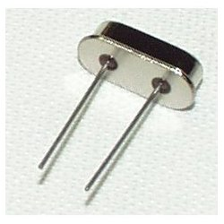

BLUETOOTH HC-05 MODULE:

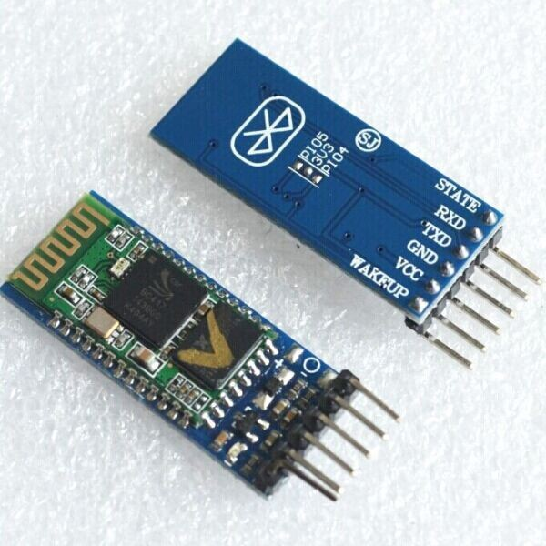

Hardware Features:
- Typical -80dBm sensitivity
- Up to +4dBm RF transmit power
- Low Power 1.8V Operation ,1.8 to 3.6V I/O
- PIO control
- UART interface with programmable baud rate
- With integrated antenna
- With edge connector
DC MOTOR:
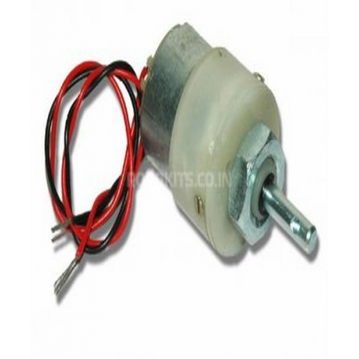
- DC supply: 4 to 12V
- RPM: 100 at 12V
- Total length: 46mm
- Motor diameter: 36mm
- Motor length: 25mm
- Brush type: Precious metal
- Gear head diameter: 37mm
- Gear head length: 21mm
- Output shaft: Centred
- Shaft diameter: 6mm
- Shaft length: 22mm
- Gear assembly: Spur
- Motor weight: 100gms

LED:

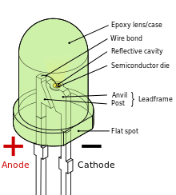

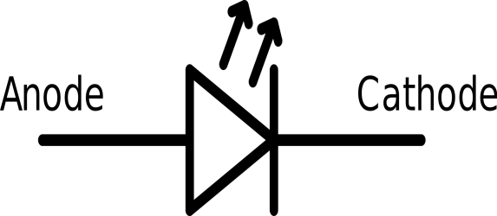
SPECIFICATIONS:
Low-current
Typically rated for 2 mA at around 2 V (approximately 4 mW consumption)
Standard
20 mA LEDs (ranging from approximately 40 mW to 90 mW) at around:
- 1.9 to 2.1 V for red, orange, yellow, and traditional green
- 3.0 to 3.4 V for pure green and blue
- 2.9 to 4.2 V for violet, pink, purple and white
Ultra-high-output
20 mA at approximately 2 or 4–5 V, designed for viewing in direct sunlight
5 V and 12 V LEDs are ordinary miniature LEDs that incorporate a suitable series resistor for direct connection to a 5 V or 12 V supply.

CIRCUIT DIAGRAM FOR PROJECT ‘VOICE OPERATED ROBOT’:

