Manual for the mini STEM – Arduino LED Game Platform Activities

Activities supported in the included sketch. These are run via the main menu corresponding to the selection of items 1 through 6.

Menu Operation:
After the initial startup sequence, six LEDs will be dimly lit. One for each of the mini apps available for selection. There is also a selection cursor in the form of a brightened LED. Move this 'cursor' left with btn2, and right with btn3. When you have highlighted the item of interest hit btn1 to select it. That applet will run.
To exit an activity and return to the main selection menu, hold down btn4 for more than 2 secs. Due to the nature of different activities the exit could be sooner or a few seconds more.

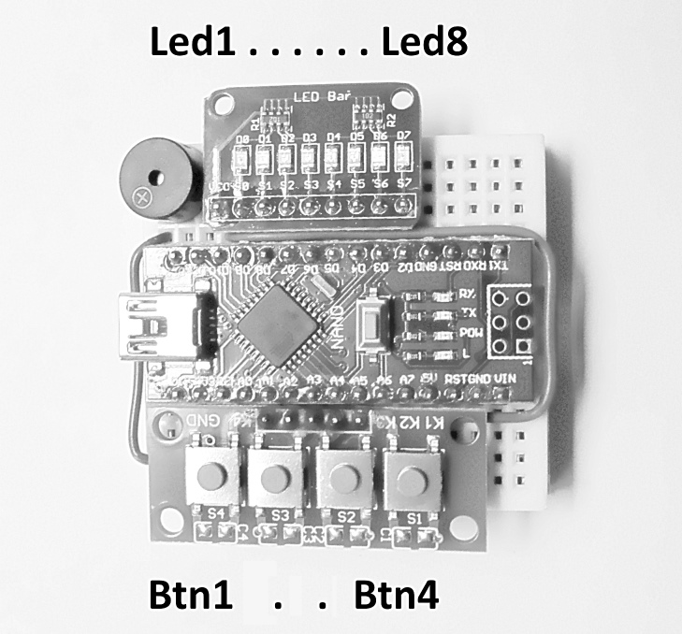
Here are the six activities as currently implemented:

#1 HW_Support_Demo
Demonstrates LED display and audio support functionality.
Btn1 dimly lights the LEDs and sounds a low pitch boop noise while the button is held.
Btn2 moderately lights the LEDs and sounds a beep noise while the button is held.
Btn3 brightly lights the LEDs and produces a modulated buzz sound.
To make use of these effects for your own application refer to the code.

#2 Speed_Scan
A blip scans from left to right. The goal is to hit a button when either the 5th or 6th LED is lit.
Hit it on one of the right spots to speed things up to a winning max.
Misses slows things down, and can put you even further from winning.
Your progress is shown as you go by a number of dimly lit LEDs, starting from the left. Total success is achieved when all the LEDs are lit dim.

#3 React_Now
Test your Reaction time, by attempting to hit a button when the first LED lights up.
The first LED is lit for 100 milli-secs, then additional LEDs lite every 20 msecs.
A number of LEDs remain lit while you hold the button down. Say there are five LEDs lit, that indicates that it took you at lease 100+(4*20); 180 milli-secs for you to react. You can try to beat or match your best reaction. You can have head to head competitions or use to settle a dispute.

#4 SeeIt_TagIt (aka Capture & Release)
You must attempt to hit an associated button when an LED lights up, within limited given amount of time. If successful the LED will remain lit, if it was not previously lit, else it will no longer remain lit. I make a game of it by trying to get all 4 color LEDs lit, without having “un-lit” one accidentally. Followed by trying to accomplish the reverse without a fault. Ending with them all off as when we started.

#5 pingPong
Fun as an individual challenge, and a great two player competitive game; where the ball (single blip of light) goes from one side to the other, faster and faster, each time it gets 'hit' back.
I first implemented this single row of lights game across the front panel button-lights of an aerospace super-mini computer in the 1970s.
To hit the ball back and forth, the appropriate paddle must hit (button pressed, btn1/btn4) it when it is in the end position (last LED). The first side to miss loses, and the lights on the winning side are flashed.
The winner of a rally is always the server for the next. After a rally, the number of times the ball was hit back & forth is reflected on the display.

#6 FortuneTeller
Uses analog IN along with random() and then Human Heuristics. The use of button1 gives a “Magic-8 ball” type response (Red: NO YEL: Maybe Grn: YES Blue: Try again).
You press the button, you propose a question or ponder your request . . . let go of the button and your answer will be divined. This process can be repeated over and over. Note that would-be answers flow by while posing the question. The final response is directly influenced by the user, while they hold the button down asking their question. Albeit not consciously deliberate.
Use btn2 for 1/6 out comes ~ like dice, useful for determining one's fortune or options in games. The number of LEDs 1-6 will be lit in a pattern akin to those on dice.
Use btn3 for 1/8 could be used like Tarot or Horoscope card telling or a Game/Fortune wheel.

