PENCIL AND ERASER DISPENSER
By: Adrian & Daniel

We built this touch free pencil dispenser because of the Corona virus that has changed our lives in some way or the other.

This invention will help students to be safe in classrooms as we head back to school in the midst of this pandemic. This gadget is a great tool to have in a classroom as a lot of children who lose or break their pencils, or forget to bring them from home, will need to borrow pencils, and in that case this dispenser will help students and teachers obtain pencils with out having to touch anything.

Here are the step by step instructions on how we made this Pencil Dispenser.

Steps

- Cut out the cardboard pieces and measure them as mentioned at the bottom of the steps.

- Using the hot glue gun, glue the 21x8 cm piece to the 21x21 cm, then glue the two 8x11 cm, also to the 21x21 cm and put the 20x7 cm like a ramp against the 21x8 cm Glue it together.

- Add another 20x7 cm against the two 8xll cm.

- Then make a pencil holder, for which you will need a 20x7 cm, a 20x7.3 cm and two 8x1 cm. Put all this together.

- Now glue the pencil holder on top of the 20x7 cm.

- Put the 3x1 cm on the 20x7 cm board against the two 8x11 cm.

- Now make two holes on the 20x7 cm board that is in front of the 3x1 cm board.

- Insert small wooden sticks in the hole and then super glue it down.

- Place the 18x6 cm between the 3x1 cm board.

- Make holes in the 18x6 cm board, 2 cm across from the wooden sticks that were inserted earlier, then put two wooden sticks in these holes and super glue them down.

- Take two rubber bands and fold them once, now put the rubber bands around the 4 wooden sticks.

- Put the 21x21 cm board & the two 21x2 cm boards on the sides and glue them.

- Add the other 21x21 cm board under the above 21x21 cm board.

- Take the 8x11 cm board and glue it to the side of the dispenser.

- Glue a sharpener to the 5x6 cm.

- Now glue a 5x8 cm piece of cardboard behind the 5x6 cm.

- Then glue a 5.5x7.5 cm to the right of the 5x6 cm board.

- Make a box for the pencil shavings to drop into.

- Then build three low narrow walls around the sharpener box and put in some erasers.

- Now decorate as you wish and you are all done.

Materials & Cardboard Measurements

- Cardboard Wooden sticks, Popsicle sticks, Sharpener, Erasers, Pencils, 1 pop bottle cap

- 21 x 21 cm = 1 piece
- 8 x 11 cm = 2 pieces
- 21 x 21 cm = 1 piece
- 20 x 7 cm = 3 pieces
- 20 x 7.3 cm = 1 piece
- 8 x 1 cm = 2 pieces
- 3 x 1 cm = 2 pieces
- 18 x 6 cm = 1 piece
- 21 x 21 cm = 1 piece
- 21 x 2 cm = 2 pieces
- 8 x 11 cm = 1 piece
- 5 x 6 cm = 1 piece
- 5 x 8 cm = 1 piece
- 5.5 x 7.5 cm =1 piece
- 21 x 2.5 cm = 1 piece

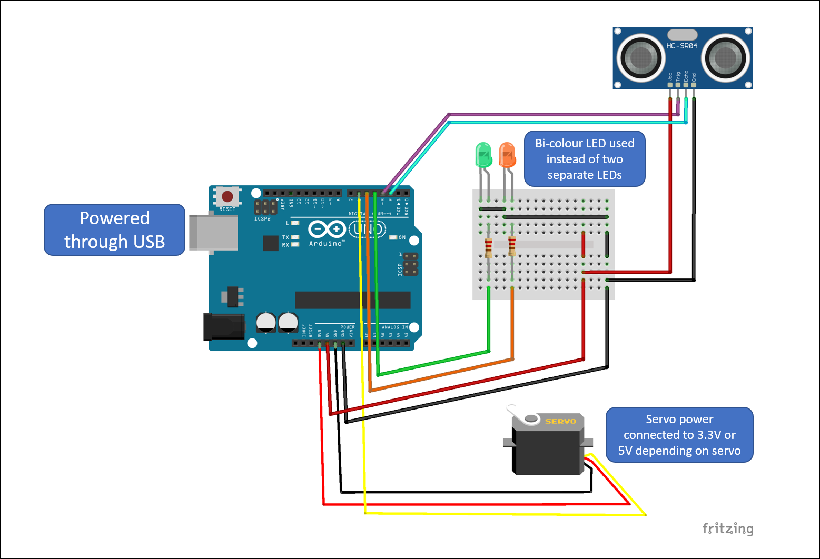

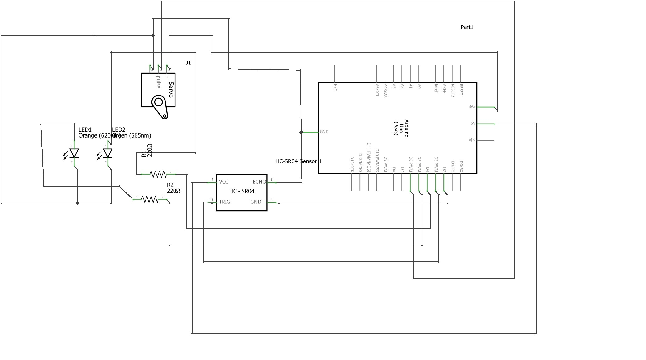

// ---------------------------------------------------------------- //
// Arduino Ultrasoninc Sensor HC-SR04
// Pencil Dispenser project using Ultrasonic sensor HC-SR04
// ---------------------------------------------------------------- //

#include <Servo.h>
#define echoPin 2 // attach pin D2 Arduino to pin Echo of HC-SR04
#define trigPin 3 //attach pin D3 Arduino to pin Trig of HC-SR04
#define RedLed 4 // This pin will be set to HIGH to light the Red LED
#define GreenLed 5 // This pin will be set to HIGH to light the Green LED

Servo servo1;

// defines variables
long duration; // Variable to store measurement of how long the sound wave travels
int distance; // variable to store the calculated distance from sound wave duration above

void setup() {
servo1.attach(6);
pinMode(trigPin, OUTPUT); // Sets the trigPin as an output
pinMode(echoPin, INPUT); // Sets the echoPin as an input
pinMode(RedLed, OUTPUT);
pinMode(GreenLed, OUTPUT);
}

void loop()
{

//long duration; // - the variables can also be defined here instead of above - but right now commented out
//int distance;

digitalWrite(trigPin, HIGH);
delay(100);
digitalWrite(trigPin, LOW);
duration = pulseIn(echoPin, HIGH); // Measure the pulse input in echo pin
distance = (duration/2) / 29.1; // Distance is half the duration (duration is the sound traveling to object and then returning to the sensor as an echo) divided by 29.1 (from datasheet)
if (distance <= 10 && distance >= 0) // if distance less than 0.1 meter and more than 0 (0 or less means over range)

{

servo1.write(30); // The angle of the servo motor determines how much the platen is pushed into the dispenser. We had to trial and error this.
digitalWrite(RedLed, HIGH); // Once platen is pushed the Red Led is lit immediately and green one is off in the line below
digitalWrite(GreenLed, LOW);

delay(15000); // Here we put a delay of 15 seconds before the next pencil can be dispensed. This is to prevent kids from just playing with it and getting more pencils.
// This can be changed instead to a push button switch which must be pushed by the teacher to activate the machine again. It will still be touchless
//because the teacher is not touching the pencils once they are in the machine
}
else
{
servo1.write(0 );
digitalWrite(GreenLed, HIGH); // LEDs status are reversed once delay is over and machine is ready again
digitalWrite(RedLed, LOW);
}

}

