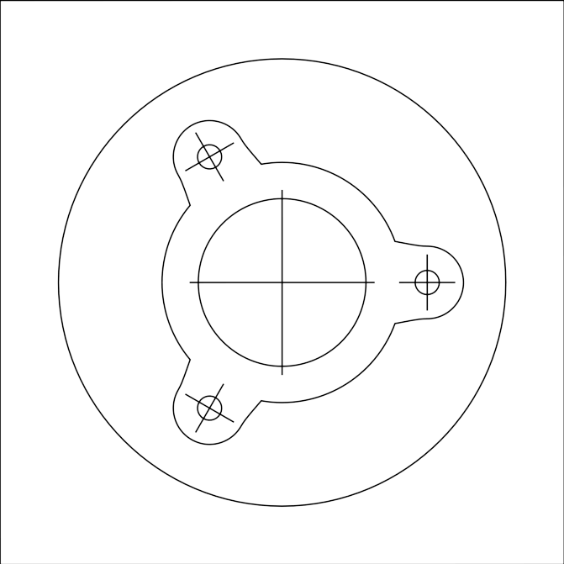
NGV Support Collar

Paper size: A4
print control size 70mm
∅ - bore diameter
∅3mm

