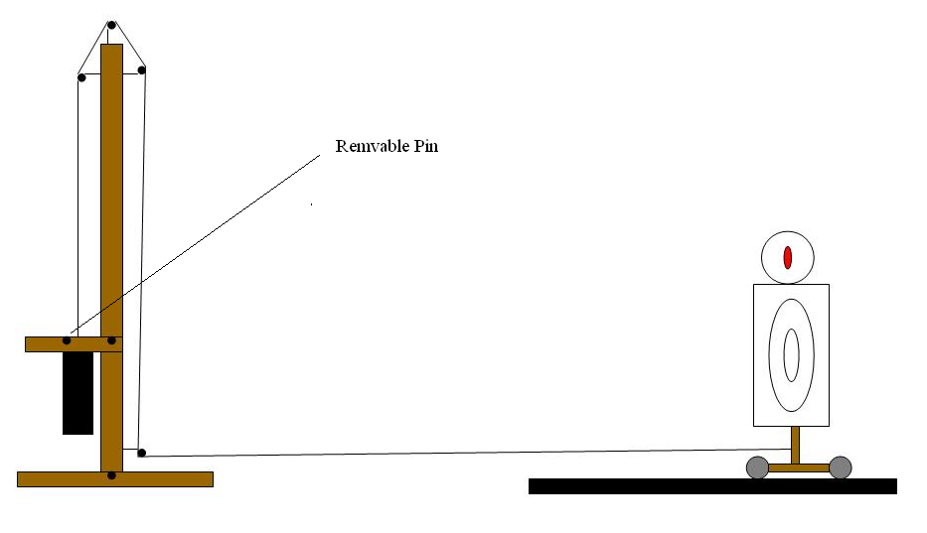
Moving Target Plan Mk2. [sliding]

The way this target works is dependant on a series of pulleys, however it doesn’t have to be complicated. The target is a simple upsidown ‘T’ with the target attached to the front, on wheels. You could construct a track for it but this isn’t really necessary as it will tale the shortest rout to the tower. A string is attached to the targets base. The tower is again an upsidown ‘T’ with 4 pulleys attached to it. The pulley at the bottom right is the first. The string form the target goes to this one first. Thread the string on the inside of the pulley. This should then be threaded to the outside of the next two pulleys. The end of the string is attached to a heavy weight that is substantial enough to pull the target. Above the weight is a beam that extends from the main ‘T’ this is where the Removable Pin is placed. It should go through the beam and over the top of the weight. This will prevent it rising prior to the pin being pulled. Varying the weight of the weight will determine the speed at which the target moves.

Good Luck T.Cox

