Germ Ninjas
Perfect Sick Day Snot

Your challenge:
Your challenge is to decide how much PVA glue, borax solution and water you need to use to create the most realistic, disgusting snot.

To make your snot, you will need:
- PVA glue
- Borax solution
- Water
- 3 drops green food colouring
- 3 drops essential oils (I recommend eucalyptus, menthol or peppermint)

Method:
- Dissolve PVA glue in water, stirring with a lolly stick
- Add food colouring and essential oils and stir until fully mixed
- Add borax solution and begin stirring quickly, right away

Top tip:
Think like a scientist. To make this a fair test, change only one thing at a time.

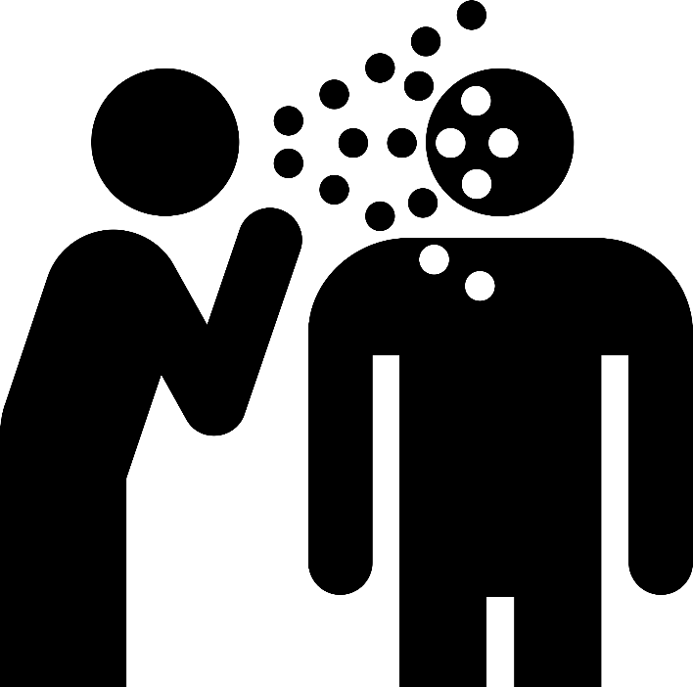
Test | How much PVA glue? | How much borax solution? | How much water? | What did my snot look like?
1
2
3
4
5

To make the best snot, you should use:
_____________ of PVA glue
_____________ of borax solution
_____________ of water

I think this recipe made the best snot because __________________________________________________________________________________________________________________________________________________________________________________________________________________________________________________________________________________________________________________________________________________________________________________________________________________________

