Unit Code: 2019 CIS006-3 - AI and Mobile RobotsCIS007-2

Assignment: Assignment 2, Robot navigation and path planning

(Unit Coordinator: Dr Vitaly Schetinin)

Student name: Oliver Marchington
ID: 1618317
Email: oliver.marchington@study.beds.ac.uk

1. Introduction

This report is on how creating a machine learning (ML) algorithm combined with the use of ros can recognise traffic signs and control a robot based on the sign recognised. For example if a turn right sign is recognised then the robot will turn right, if a turn left sign is recognised then the robot will turn left, if neither are recognised then the robot will continue forward.

There are many parts to this assignment, each part does its own individual objective and is then connected up by ros. The first part is to create a model from a tensorflow machine learning algorithm, this was built up from the example given by the university. The second part is to create a program which iterates through the frames from the camera and put them into the tensorflow model to return a prediction. The third part is to install ros on the computer and test out the connection from the computer to an arduino board. The fourth part is to create an arduino program which can be used to receive a command from the computer through ros.

The dataset that’ll be used is the official traffic sign recognition from the INI (2019) (Institut Fur Neuroinformatik), this dataset has 43 classes however only two are needed; 00033 and 00034 folders in the dataset are left and right turn signs.

2. Designing a Solution

In designing a solution to create an autonomous vehicle the first step is to create a machine learning algorithm using tensorflow. This is written in python and is built up from the example provided by the university. Changing the model to fit the same design as the deep learning algorithm from assignment 1 will achieve a high accuracy. The computer used for this project is a raspberry pi 4 running Duster / debian 10. This board is fast enough for processing the machine learning algorithm.

The second step is designing the program which can iterate the frames from the pi camera and put them through the model saved model to make a prediction.

The third step is once ros is installed there are tutorials online to test the connection between the computer and the arduino. Once this test has been completed and passed the next step can begin.

The final step is to make the code for the arduino which will receive an input over serial from
the computer using ros. From this input the robot will do one of three things: move forward,
turn left or turn right. As mentioned above in step 3, the ros.h file will need to be included for connection to the raspberry pi.

Step 1 – the training script:
The training script is designed to access all of the dataset, this is the dataset from INI (2019)
the official dataset for traffic sign recognition. It compiles of 50,000 images from 43 different classes. The script I wrote was written in python using a variety of libraries:
os – this is for linking the python script to the correct directory where the dataset is located.
Matplotlib – this is for displaying the data from the training model.
Tensorflow and keras – these are the libraries used to create the artificial neural network model, they are used to design the model.
Numpy – this library is for turning images into an array which can then be put through the model to retrieve a prediction.

The model used in the training script (Appedix 6.1) is designed after the most successful machine learning algorithm from assignment 1. This consists on convolutional 2D with a (5,5) input and an activation of relu then pooling, once this is done the input goes through another convolution with a (3,3) input with the same activation and pooling. This happens one last time before being flattened and then the density is applied to the amount of classes there are, in this case 43.

I used a combination of the model from assignment 2 for the layout since this had the highest accuracy and the layout of the code I based on the example from Pyimage traffic sign (2019), in his exmaple he shows how to make an image classifier that achieves 95% accuracy, however since in assignment 1 I was able to make a more accurate algorithm I chose to use the same model as before. The next step was to compile the model. This is the part that sets the optimiser, a sgd was the most fitting since this was similar to the optimiser used in assignment 1. Sgd stands for Stochastic gradient descent. Also within the compiler the loss needs to be set, choosing a sparse_categorical_crossentropy loss is the best fitting since the categories are as integers and the model will output a prediction for each class as a float between 0 and 1. 1 being 100% accuracy.

Once the compiler is complete a generator needs to be applied for the model to start processing the image inputs. The generator consists of multiple parts:
training_set – this is the link to the dataset used for training,
steps_per_epoch – this is the number steps per epoch that are required,
epochs – these are how many times the program will iterate through a full set of data,
validation_data – this is the link to the dataset used for validation,
validation_steps – the number of steps used for validation, validation happens at the end of each epoch.

Generally, a complete wipe of the whole dataset needs to be complete per epoch. Hence for example a dataset of 1024 images will require: Batch size = 32, Steps per epoch = 32, epochs = 1. Each step includes the whole batch size, so with a batch size of 32 the steps will be 32. On the other hand, it’s best to have a bigger batch size than the number of classes, this is because if the batch size is smaller then each step can’t include an image from each class.

Once the model has finished training, using matplotlib the program will make a graph of the outputs, this shows the history of the training from start to finish. The graph consists of accuracy, validation accuracy, loss and validation loss, this is split up per epoch to show how the training progressed. The final stage is to save the model as a .h5 file which can be accessed later on for the prediction process. Saving the model means that each time the prediction program is ran the training program doesn’t need to be ran again. The training program can take up to 10 minutes per epoch on a raspberry pi.

Step 2 - The next program is the prediction and publisher script; this is appendix 6.2.
From the example given on Pyimage object recognition (2017), the best way to access the raspberry pi camera and frames are by using opencv2, this is a library designed for image processing within python. The first stage is to load the model using model.load(). The second stage is to iterate through the frames from the pi camera using opencv and then resize the frame to the same size as the input sizes used in the training stage, 32 x 32 pixels. Once this is done the new resized frame is put through the model using model.predict () which outputs a matrix, each element of the matrix is a float from 0 to 1, the element index is the same as the class it’s representing, hence the first element is class one and the number is the prediction of certainty of the image being from that class. E.g. [[1.0, 0.0, 0.0,…]] shows that the prediction is 100% for class one and zero for the others. In real cases though the output will show certainty for multiple classes and not always 100% hence the added if statement of if the certainty is more than 95% or 0.95 then return the index. This index is put through a list of lists with the actual names of the classes, e.g. ’20 mph speed’ or ‘turn left’. One this is complete there is an if statement which is ‘if turn left or turn right then publish that sign to ros else publish ‘ahead’’. The publisher will publish the string to ros under the topic called robot. In the third step the robot will listen to the topic.

Step 3 – The last step is the robot program script; this is appendix 6.3.
This is written in C++ and is a .ino file for the arduino uno. The program requires the ros library which can be found in the libraries manager within the ide. Once this is imported there are example files, I chose to expand on the led blink file since this would do a similar objective to what I needed. The program continues to loop until the power is disconnected, firstly it listens to the topic robot, when it catches a command from that topic it will have an if statement to see what the command says. If the command is left then the script runs the turn left method, if the command is right then it’ll run the turn right method and else it’ll run the forward method. These three methods are very similar to each other, they tell the digital pins to be either LOW (ground) or 100 (PWM) this is for so that the robot isn’t too fast by telling the motor driver to only let a bit of voltage out. The order of these outputs are what makes the robot turn left and right or go forwards, this is due to the orientation of the voltage going to the motors.

3. Experiments

The objective of the training program is to make a sequential model, train the model, save the model and do a final test using a random image from a test set. The program also outputs a graph however this doesn’t affect the training process it’s just for clarifier the process afterwards for the ease of understanding the output.

Training the program using the terminal in duster (the Linux OS) shows data while the training is happening, the data shown is in image 1 below.

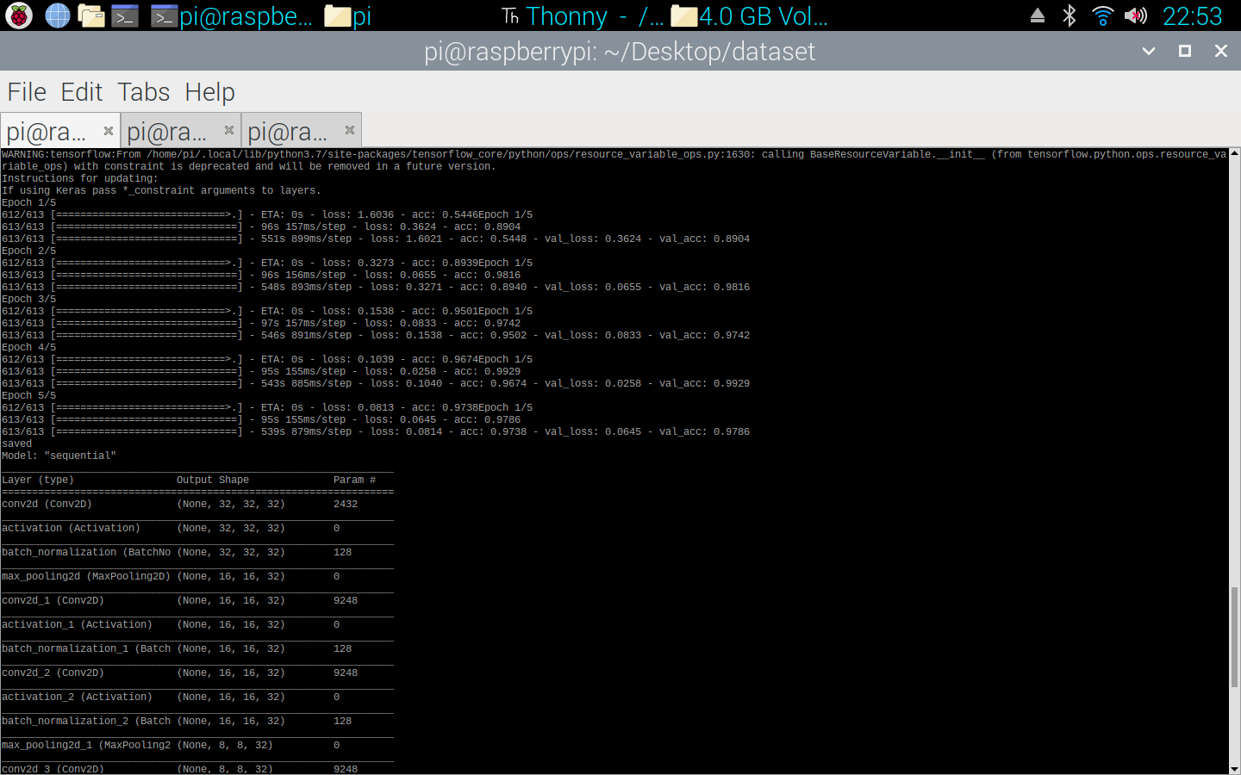

This shows the step number the training is on for that epoch, each epoch it creates a new line of data. At the end of the steps the validation happens which then ends the epoch and moves to a new one. The program then prints the summary of the model (image 2).

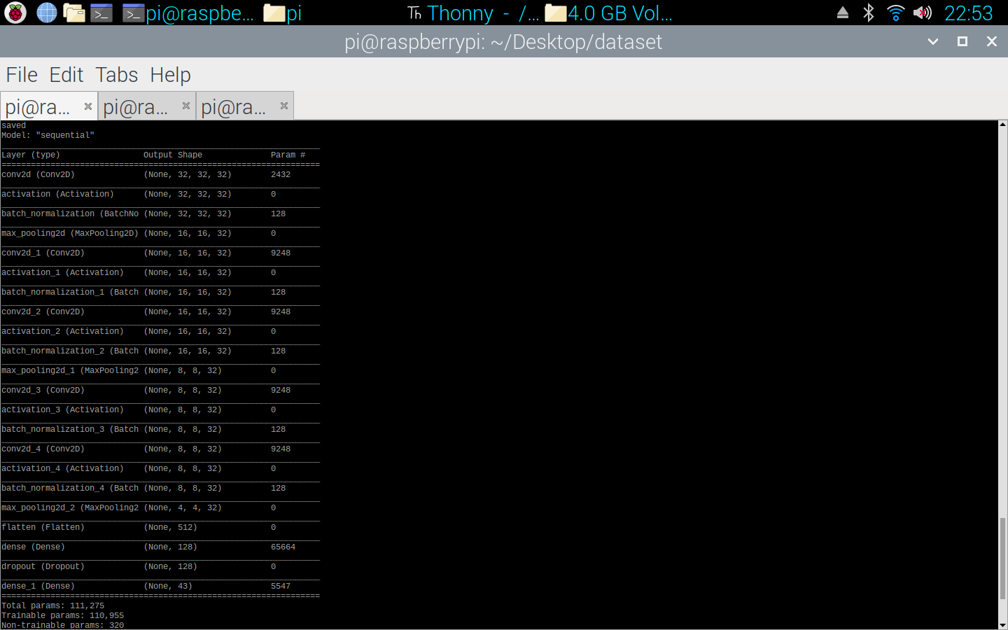

Image 3 shows a matrix output from a test image once it’s been through the model prediction.

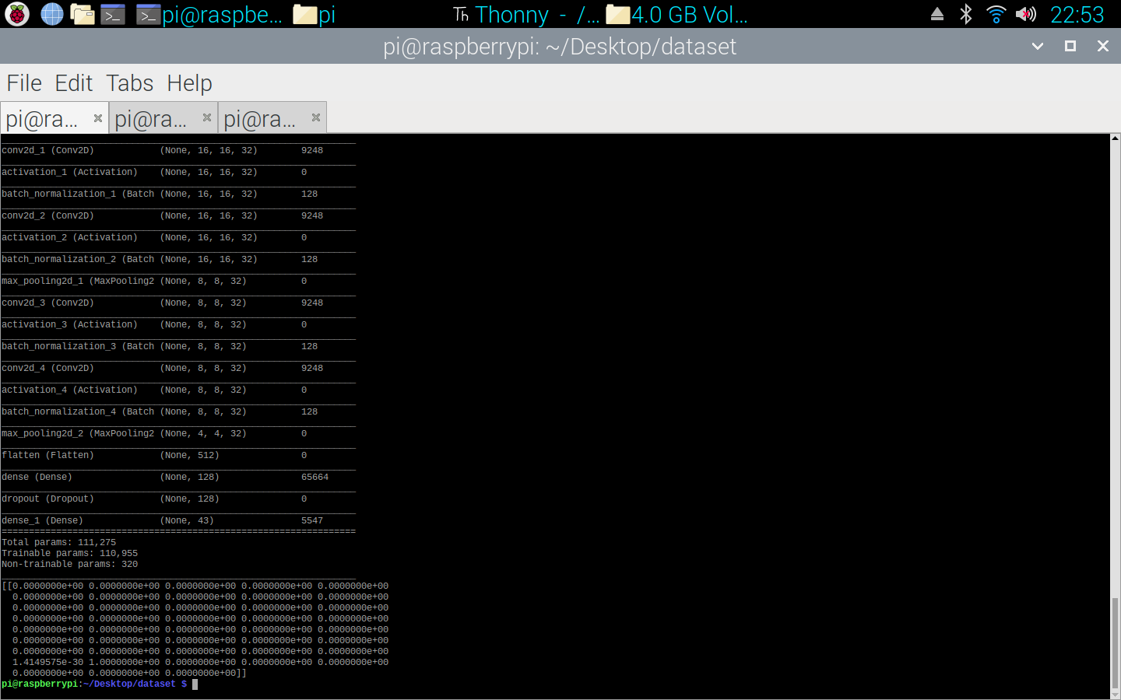

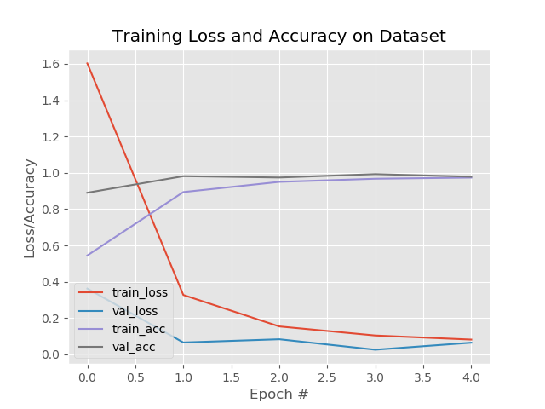

Image 4 shows the graph from the training of the model. This shows over the 5 epochs the accuracy increasing and the loss decreasing.

The next experiment shows the recognition working, in image 5 below the opencv library shows the video feed in a window and prints the predicted output in the terminal.

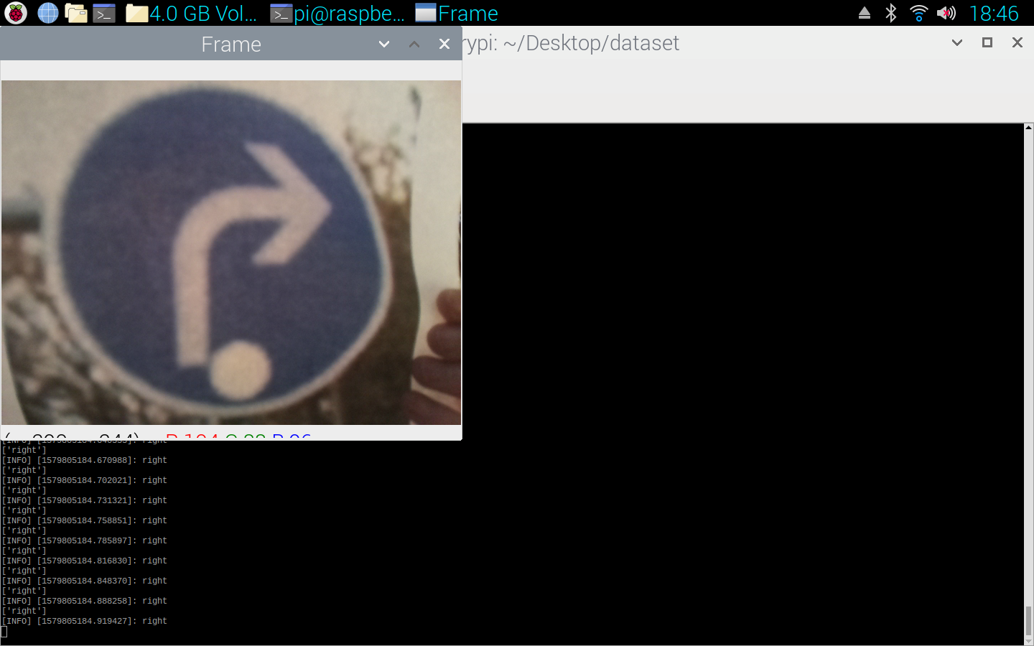

4. Conclusions

Designing a solution to a traffic sign recognition program required a combination the recognition script provided from the university and my own knowledge of artificial neural networks.

From expanding the traffic.py script I concluded the highest accuracy possible is to use the model created in assignment 1, this model used the following settings:

noClasses = 43
epoch = 5
steps = 613
imgSize = 32
batchSize = 64
opt = 'sgd'

From these settings the validation accuracy was 100% however the accuracy while testing with a live stream was lower than this. There are many improvements that could be made to increase this accuracy, the first being object recognition as opposed to image classification which was used here. Object recognition will allow the network to look for the class within the image, currently the program used the whole image to make a prediction. With object recognition the program will split the image up into sections and check each section for a classifier.

In conclusion to the above system, the connection between the raspberry pi and arduino worked exactly as it was suppose to using ros, the training of the image classifier also worked properly and predicted the correct output when inputting a solid image, however the one script that could be improved is the way the raspberry pi takes one of the frames from the camera and inputs it into the model prediction.

5. References

Vitaly Schetinin, (2019), Unit feed, https://docs.google.com/presentation/d/14mcS2TNuLoQWMEErbcMikn_beZZ6FcG9yvz3c9jgws0/edit#slide=id.g409225d44f_2_53 (Assessed 15th October 2019).

INI (2019), Dataset, available at: http://benchmark.ini.rub.de/?section=gtsrb&subsection=dataset (Accessed 17th October 2019)

Pyimage traffic sign (2019), Traffic Sign Classification with Keras and Deep Learning, available at: https://www.pyimagesearch.com/2019/11/04/traffic-sign-classification-with-keras-and-deep-learning/ (Accessed 1st January 2020)

Pyimage object recognition (2017), Raspberry Pi: Deep learning object detection with OpenCV, https://www.pyimagesearch.com/2017/10/16/raspberry-pi-deep-learning-object-detection-with-opencv/ (Accessed 2nd December 2019)

6. Appendix

Below are the scripts used for each machine learning solution. I have split them up for ease of reading.

6.1 Training script
# ### Import Libraries

# Importing the Keras libraries and packages
import tensorflow as tf
from tensorflow.keras.models import Sequential
from tensorflow.keras.layers import Conv2D
from tensorflow.keras.layers import MaxPooling2D
from tensorflow.keras.layers import Flatten
from tensorflow.keras.layers import Dense
from tensorflow.keras.layers import BatchNormalization
from tensorflow.keras.layers import Dropout
from tensorflow.keras.layers import Activation
import numpy as np
from tensorflow.keras.preprocessing import image
from tensorflow.keras.preprocessing.image import ImageDataGenerator
from tensorflow.keras.utils import to_categorical
import itertools
import random, os
import matplotlib.pyplot as plt
import matplotlib.image as mpimg

noClasses = 43
epoch = 5
steps = 613
imgSize = 32
batchSize = 64
opt = 'sgd'

# ### Create a classifier object os Sequential class

train_Dgen = ImageDataGenerator(rescale = 1./255,
shear_range = 0,
zoom_range = 0,
horizontal_flip = False)

test_Dgen = ImageDataGenerator(rescale = 1./255)

training_set = train_Dgen.flow_from_directory('/home/pi/Desktop/dataset/GTSRB/Final_Training/Images',
target_size = (imgSize, imgSize),
batch_size = batchSize,
class_mode = 'sparse')

test_set = test_Dgen.flow_from_directory('/home/pi/Desktop/dataset/GTSRB/Final_Training/Images',
target_size = (imgSize, imgSize),
batch_size = batchSize,
class_mode = 'sparse')

#training_set = to_categorical(training_set, 43)
#test_set = to_categorical(test_set, 43)

model = Sequential()

# ### Add Layers
model.add(Conv2D(32, (5, 5), input_shape = (imgSize, imgSize, 3), padding="same"))
model.add(Activation("relu"))
model.add(BatchNormalization(axis=-1))
model.add(MaxPooling2D(pool_size = (2, 2)))

model.add(Conv2D(32, (3, 3), padding="same"))
model.add(Activation("relu"))
model.add(BatchNormalization(axis=-1))
model.add(Conv2D(32, (3, 3), padding="same"))
model.add(Activation("relu"))
model.add(BatchNormalization(axis=-1))
model.add(MaxPooling2D(pool_size = (2, 2)))

model.add(Conv2D(32, (3, 3), padding="same"))
model.add(Activation("relu"))
model.add(BatchNormalization(axis=-1))
model.add(Conv2D(32, (3, 3), padding="same"))
model.add(Activation("relu"))
model.add(BatchNormalization(axis=-1))
model.add(MaxPooling2D(pool_size = (2, 2)))

model.add(Flatten())
model.add(Dense(units = 128, activation = 'relu'))
model.add(Dropout(0.5))
model.add(Dense(units = noClasses, activation = 'softmax'))

# ### Compile the model
model.compile(optimizer = opt,
loss = 'sparse_categorical_crossentropy',
metrics = ['accuracy'])

# ### Fit the data to the model

H = model.fit_generator(training_set,
steps_per_epoch = steps,
epochs = epoch,
validation_data = test_set,
validation_steps = steps)

# Save the model

model.save('my_model8.0.h5')
print('saved')

model.summary()

N = np.arange(0, epoch)
plt.style.use("ggplot")
plt.figure()
plt.plot(N, H.history["loss"], label="train_loss")
plt.plot(N, H.history["val_loss"], label="val_loss")
plt.plot(N, H.history["acc"], label="train_acc")
plt.plot(N, H.history["val_acc"], label="val_acc")
plt.title("Training Loss and Accuracy on Dataset")
plt.xlabel("Epoch #")
plt.ylabel("Loss/Accuracy")
plt.legend(loc="lower left")
plt.savefig('graph.png')

# ## Testing the model

# ### Load an image randomly from a folder with mixed pictures

folder = r"/home/pi/Desktop/dataset/test/mixed"
imgs = os.listdir(folder)
img = os.path.join(folder, random.choice(imgs))

test_image =image.load_img(img, target_size = (imgSize, imgSize))

# #### Here is the picture picked

#test_image

test_image = image.img_to_array(test_image)
test_image = np.expand_dims(test_image, axis = 0)

# ### Classify the Image

result = model.predict(test_image)
training_set.class_indices

print(result)

6.2 Streaming recognition and publishing script
from imutils import video
VideoStream = video.VideoStream
import numpy as np
import argparse
import imutils
import time
import cv2
import tensorflow as tf
import random, os, time
import matplotlib.pyplot as plt
import matplotlib.image as mpimg
from tensorflow.keras.preprocessing import image

import rospy
import random, time
from std_msgs.msg import String

def talker(direction):
message = String()
pub = rospy.Publisher('robot', String, queue_size=10)
rospy.init_node('talker', anonymous=True)
message = direction

rospy.loginfo(message)
pub.publish(message)

imgSize = 32

class_names = ['left','right']
labelNames = open("signnames.csv").read().strip().split("\n")[1:]
labelNames = [l.split(",")[1] for l in labelNames]

# Load model
new_model = tf.keras.models.load_model('my_model8.0.h5')

# initialize the video stream, allow the cammera sensor to warmup,
# and initialize the FPS counter
print("[INFO] starting video stream...")
vs = VideoStream(src=0).start()
time.sleep(2.0)

# loop over the frames from the video stream
while True:
# grab the frame from the threaded video stream and resize it
# to have a maximum width of 400 pixels
frame1 = vs.read()
frame = cv2.resize(frame1, (imgSize, imgSize))

test_image = image.img_to_array(frame)
test_image = np.expand_dims(test_image, axis = 0)

preds = new_model.predict(test_image)
#print(preds)
lst = (preds.tolist())[0]
lst1 = []
for l in lst:
if l > 0.95:
position = lst.index(l)
#if labelNames[position] in class_names:
lst1.append(labelNames[position])

print(lst1)

if not lst1:
direction = 'ahead'
else:
direction = lst1[0]
talker(direction)

# show the output frame
cv2.imshow("Frame", frame1)
key = cv2.waitKey(1) & 0xFF

# if the `q` key was pressed, break from the loop
if key == ord("q"):
break

# update the FPS counter

# do a bit of cleanup
cv2.destroyAllWindows()
vs.stop()

6.3 Arduino script
#include <ros.h>
#include <std_msgs/String.h>

ros::NodeHandle nh;
String msgs;

int rightforwards = 9;
int rightreverse = 6;
int leftforwards = 3;
int leftreverse = 5;

void messageCb(const std_msgs::String& msg)
{
msgs = String(msg.data);
if(msgs == "left"){
left();
}
else if(msgs == "right"){
right();
}
else{
forward();
}
}

ros::Subscriber<std_msgs::String> sub("robot", &messageCb);

void setup()
{
pinMode(13, OUTPUT);
pinMode(rightforwards, OUTPUT);
pinMode(rightreverse, OUTPUT);
pinMode(leftforwards, OUTPUT);
pinMode(leftreverse, OUTPUT);
nh.initNode();
nh.subscribe(sub);
}

void loop()
{
nh.spinOnce();
delay(1);
}

void left(){
analogWrite(rightforwards,80);
digitalWrite(rightreverse,LOW);
digitalWrite(leftforwards,LOW);
analogWrite(leftreverse,80);
}

void right(){
analogWrite(rightreverse,80);
digitalWrite(rightforwards,LOW);
digitalWrite(leftreverse,LOW);
analogWrite(leftforwards,80);
}

void forward(){
analogWrite(rightforwards,80);
digitalWrite(rightreverse,LOW);
analogWrite(leftforwards,80);
digitalWrite(leftreverse,LOW);
}

