Table Project

Multiplication with Mix Numbers

A. Use what you know to determine the following products.

- 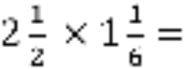
- 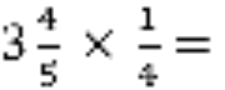

- 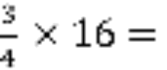

- 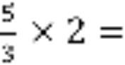

- 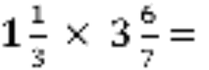

- 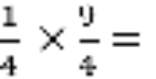

B. Choose two problems from Question A to draw a picture to prove that you calculations are right. What did you notice about your drawings and products?

