Table Project

Preparing Your Lumber

Solve this problem and draw a picture to illustrate what your answer means:

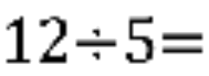

Suppose you ask, “How many ¾’s are in 14?” You can write this as a division problem, 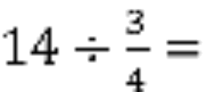

Draw a picture to show the answer to this problem.

You have 9 pieces of lumber to make table legs. How many table legs can you make if each leg needs to be the given measurement below?

1/3 of a stick of lumber

1/4 of a stick of lumber

1/5 of a stick of lumber

1/6 of a stick of lumber

1/7 of a stick of lumber

1/8 of a stick of lumber

Your friend also has 9 pieces of lumber. How many table legs can she make if each leg needs to be given the measurement below?

2/3 of a stick of lumber 3/4 of a stick of lumber 4/3 of a stick of lumber

Use what learned to complete the following calculations

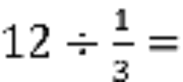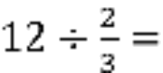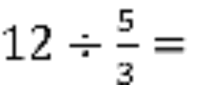

What does the fractional part of your answer means in terms of your lumber pieces?

